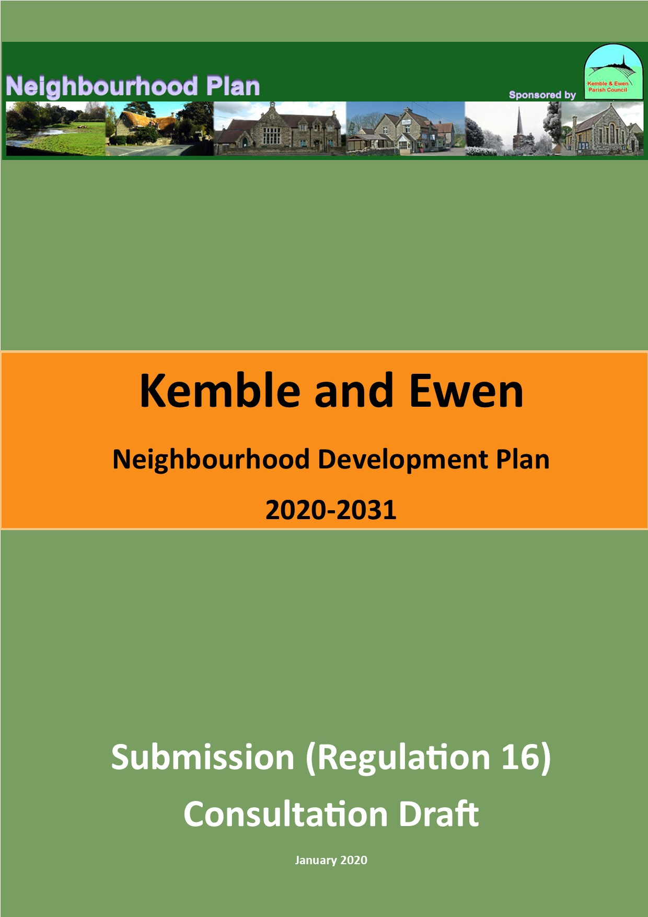

Foreword
This is the submission consultation version of the Kemble and Ewen Neighbourhood Plan (KENDP). It represents the efforts of all of you who have engaged with the process so far and will, we hope, enable and encourage you to continue to be involved in the development of the plan.
It is first and foremost a plan for the parish, by the parish. It has been prepared locally with the assistance of the parish council’s consultants, Kirkwells. The process is not an easy one, but it is one we believe that has much to offer everyone who cares about the villages and the environment of them.
PLEASE HELP US TO MOVE TO THE NEXT STAGE BY GIVING US YOUR COMMENTS.

Table of Contents

Page

1.0 Background 6
2.0 Kemble and Ewen Parish Neighbourhood Area 8
3.0 Kemble and Ewen Neighbourhood Development Plan: Key Issues, Vision and Objectives 12
4.0 National and Strategic Planning Policy Context 15
5.0 Neighbourhood Plan Policies 22
6.0 How to Comment on this Document………..……………………..43

Appendices
Glossary

Figure 1. Designated Neighbourhood Area © Crown copyright [and database rights] [2019] OS [1000055940] on behalf of Kemble and Ewen Parish Council (0100056844)
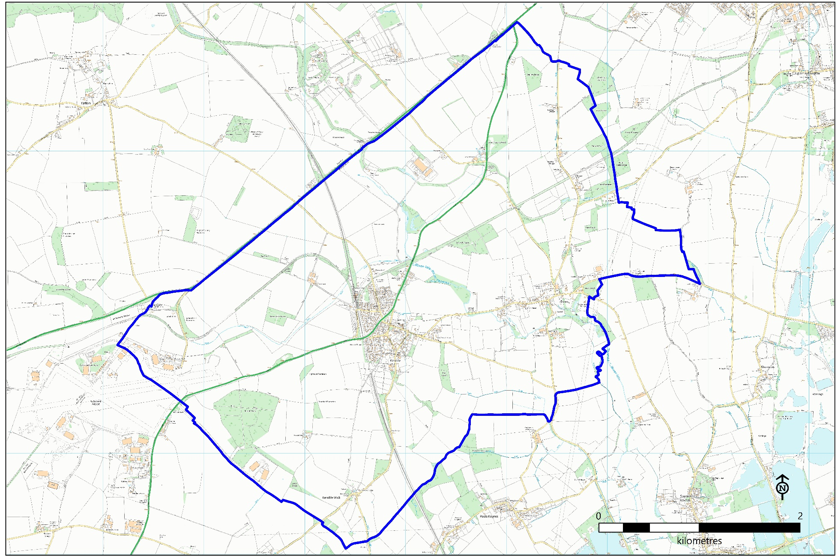

1.0 Background
1.1 The Localism Act 2011 gave Parish Councils the power to prepare a statutory neighbourhood development plan (NDP) to help guide development in their local areas. Through the KENDP, local people in Kemble and Ewen parish now have the opportunity to shape new development in the area. This is because planning applications are determined in accordance with the development plan, unless material considerations indicate otherwise.
1.2 The KENDP will sit alongside the Cotswold District Local Plan, that was adopted on 3rd August 2018
Neighbourhood Plan Process and Preparation
1.3 Kemble and Ewen Parish Council, as a qualifying body, believe this is an important power for local people to use and decided to prepare an NDP for the whole parish. The Parish Council applied to Cotswold District Council (CDC) for the parish to be designated as a neighbourhood area in September 2015. The application for designation was approved by CDC on 28th October 2015. The designated Neighbourhood Area is shown on Figure 1.
1.4 A Neighbourhood Plan Team comprising Parish Councillors and local residents was established to progress work on the plan. The steps in preparing an NDP are set out in Figure 2 below. There have been earlier consultations on the objectives of the NDP, an informal consultation, and the Regulation 14 consultation stage. To the extent necessary and appropriate the views expressed in these previous consultations have been reflected in this submission consultation version of the KENDP.
Figure 2. Neighbourhood Plan Process

1.5 In July 2019 the KENDP was screened for the purposes of Strategic Environmental Assessment and Habitat Regulations Assessment, both requirements for NDPs. This screening, available separately to the KENDP, concluded that:
“2.59 Based on the Screening Report, and taking into account responses from the statutory environmental bodies, it is determined by Cotswold District Council in accordance with SEA Regulation 9, as the ‘responsible authority’, that the Kemble and Ewen Neighbourhood Plan is unlikely to have significant environmental effects and is therefore ‘screened out’ i.e. that no Strategic Environmental Assessment is required.
2.60 In accordance with Regulation 106(1) of the Habitats Regulations, Cotswold District Council, as the ‘competent authority,’ also does not consider that an ‘appropriate assessment’ under Regulation 105 is required.”
1.6 This submission consultation gives residents, businesses, land owners, the relevant consultation bodies an opportunity to comment on this draft of the KENDP. Planning can be full of technical phrases and jargon, so we have also included a Glossary on page 77 to help when reading the plan. We welcome your comments on the draft KENDP and these can be returned to the Parish Council in one of the following ways:

[Consultation information to be inserted by CDC]
.

2.0 Kemble and Ewen Parish Neighbourhood Area

2.1 A BRIEF HISTORY. It is likely that the first settlement on the site of Kemble came after the Roman withdrawal from Britain in 410 AD. From that time the Saxons moved into the south Gloucestershire area and established permanent settlements in Poulton and Avening.
2.2 The earliest artefacts found in Kemble are late Neolithic or early Bronze Age flints found from excavations undertaken in Clayfurlong Grove in 1989. In 1992-93 a full excavation of the southern remaining part of West Hay was carried out prior to the building of the estate there and Iron Age and Anglo-Saxon burials were discovered along with various objects of these periods. These complemented the Roman and Romano British graves excavated at Fosse View House in 1983 and 1990. Archaeological excavations have identified Anglo Saxon burials on West Lane dating from the 7th Century.
Figure 3. Kemble 1903 (Source: taken from Kemble Landscape Appraisal, Tyler Grange, 2017)
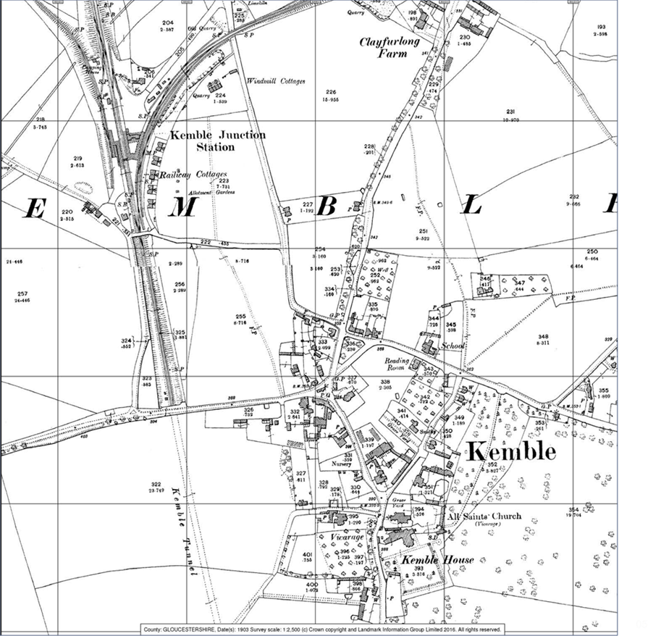
2.3 The Village was mentioned in the Domesday Book as comprising 30 villagers and 15 cottages on land held by the Abbot of Malmesbury. Historically, Kemble has been closely associated with both Ewen and Poole Keynes which were incorporated into Gloucestershire from Wiltshire in 1897.
2.4 Kemble remained agricultural through the Medieval and post Medieval period and by the turn of the 19th Century had become quite a typical Cotswold village. It included a Church, a Vicarage, School, Smithy and a local Quarry. In about 1900 a primitive Methodist chapel was built on the edge of the settlement (Figure 3).
2.5 The strongly agricultural character of the village, and the area around it, was maintained by the land owners through the 17th, 18th and 19th Centuries, a remnant of which can be found in the chaotic numbering of the older properties in the village. The character and form of the village was heavily influenced by the arrival of the railway in 1841. The alignment of the railway, and the enclosure of a part of the line near the village in a tunnel, being heavily influenced by the Lord of the Manor, Mr Gordon. He directed that the area around Kemble House should not be adversely affected by any view of the railway.
2.6 The character of the village began to change in the post-war period with housing appearing in Clayfurlong and at West Hay Grove (Figure 4).
Figure 4. Kemble 1960 (Source; taken from Kemble and Kemble Station Conservation Areas Appraisal and Management Guidance, Montagu Evans, 2016)
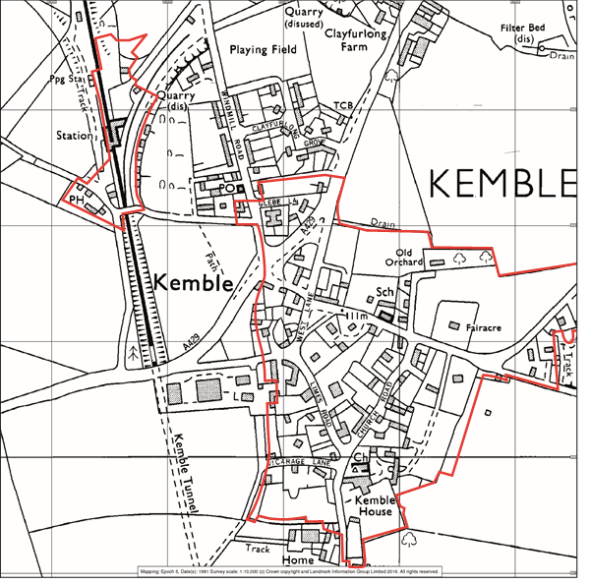
2.7 THE PRESENT DAY. The railway continues to exert a powerful influence on the village with pressure on housing and house prices arising from the easy commuting to London and points between Kemble and London and to Gloucester and Cheltenham in the west. The demand for new housing has put significant pressure on open spaces within and around the village with much infilling and conversion/redevelopment having taken place.
2.8 Currently the village maintains its essentially rural character and a clear and close association with the agricultural land around it.
2.9 Kemble has a good range of services including the Church, Village Hall, a Public House, a Village Store and Post Office, a Doctors Surgery and School. There is also a Public House and restaurant in Ewen,
2.10 The 2011 Census indicated a usual resident population for Kemble and Ewen Parish of 1,036 evenly split between males and females and with some 240 children and young people aged 0-18 years (Figure 5).
Figure 5. Kemble and Ewen Age Structure
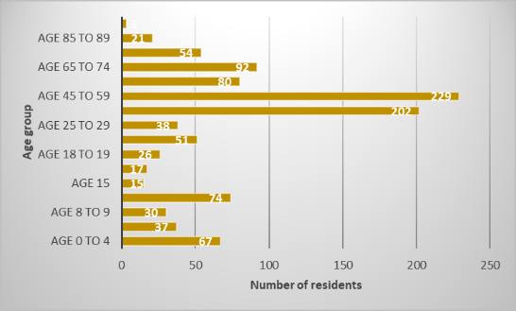
2.11 Of the 410 households some 64% were owned, 14% social rented and 17% privately rented. Some 73% of residents aged 16 – 74 were economically active. There were low rates of unemployment and only some 2.4% of full-time students. Residents had a wide range of occupations, but managerial and professional occupations predominate. The absence of any major employment centre within the Parish necessarily means that most employed residents work elsewhere.
2.12 Notable new development since 2011 includes the Top Farm area where some 50 new dwellings have been erected which will necessarily have impacted on the population figures.
2.13 The Parish is outside of, but on the edge of, the Cotswold AONB and contains within it the Kemble Special Landscape Area identified in the Cotswold District Local Plan. That area includes the infant River Thames and the nationally significant long-distance Thames Footpath.
2.14 Ewen is a smaller settlement with limited facilities including the restaurant/pub. Ewen has developed in the post-war period with new housing being erected on the areas embraced by the older developments at Ewen Manor and Mill Farm.
2.15 Overall the Parish retains a strongly rural feel and intimate connections with the surrounding countryside. There is a strong community spirit which supports a wide range of activities centred on the Village Hall, the Church, and the Tavern Public House. Residents are proud of their village and support activities and events designed to maintain its character and well-being.
2.16 There are two Conservation Areas in Kemble. One is centred on the Station area and the other on the core of the older part of the village around the Church and Kemble House. There is a Conservation Area in Ewen centred on Ewen Manor and embracing the core of the older part of the village. There are a substantial number of listed buildings within the Kemble Conservation Area and three within the Kemble Station Conservation Area. At Ewen there are some 12 listed buildings in or near to the core of the village.

3.0 Kemble and Ewen Neighbourhood Development Plan: Key Issues, Objectives and Vision

Key Issues
3.1 To kick-start preparation of the KENDP the Neighbourhood Plan Team held a workshop in June 2018. The aim of this workshop was to identify the key planning issues in the neighbourhood area and what could be done to address them. The intention being that this be used for early consultation and engagement with the wider local community to seek broad feedback and to ensure that the KENDP was setting off on the right lines. The Key Issues identified for the Kemble and Ewen area at this workshop were:
- The need to protect community facilities such as the church, pubs and shop/Post Office and to look at potential for enhancements such as at the village hall.
- The need to protect the area’s open spaces.
- The management of the future growth of the village so that it is appropriate in size and scale to retain distinct village identities and to ensure development is appropriate when considered in relation to existing and potential future infrastructure.
- Protection of the local landscape and enhanced access to the countryside for informal recreation.
- The need to ensure that new development is of good quality design so that it retains the area’s distinct character and identity.
- The need ensure that any future growth is managed in a way so that it is appropriate in relation to the neighbourhood area’s existing and potential future infrastructure.

Kemble and Ewen NDP Objectives
3.2 In order to address these key issues a set of objectives were then identified for the KENDP these are:

OBJECTIVE 1 - To protect community facilities and ensure the villages have adequate infrastructure
OBJECTIVE 2 - To protect local green spaces
OBJECTIVE 3 - To retain the scale of the villages and help manage future change
OBJECTIVE 4 – To improve access to the countryside for informal recreation
OBJECTIVE 5 -To retain the identity and character of the villages
Issues and Objectives Consultation
3.3 In order to assess whether the Neighbourhood Plan Team had identified the correct key issues and set out shared objectives a “Key Issues and Objectives” consultation was undertaken between the 7th July 2018 and the 3rd August 2018.
3.4 The consultation was conducted by distributing to every household in the designated neighbourhood area a consultation response document. The responses were deposited either in the box provided at the Village Store or returned directly to the Neighbourhood Plan Team.
3.5 A total of 121 responses were received representing therefore a good proportion of the households in the designated neighbourhood area. Of the response documents received some 51 came with additional comment the substance of which is summarised in the report on the Objectives Consultation.

3.6 In relation to the objectives identified the scores given by respondents were as follows:

Scores | 1 | 2 | 3 | 4 | 5
Objective 1 | 54 | 30 | 22 | 10 | 6
Objective 2 | 43 | 27 | 21 | 17 | 12
Objective 3 | 70 | 25 | 7 | 8 | 10
Objective 4 | 24 | 23 | 23 | 18 | 33
Objective 5 | 32 | 21 | 17 | 24 | 26

3.7 It was clear from the response to the survey that Objective 3 was considered overall the most important objective with Objectives 1 and 2 ranking second and third and being fairly evenly ranked. The rankings for Objectives 4 and 5 were more evenly spread with no overall clear view about their importance. It is, however, relevant to note that a number of responses noted that they had ranked the objectives in response to the request to do so but thought them all important.

3.8 The additional comments ranged over a number of topics summarised in Appendix 1 of the Objectives Consultation Report. Easily the most frequently mentioned comment, which was requested to be considered as part of the objectives, related to traffic with frequent references to traffic speed and the volumes of traffic and also car parking with frequent references to the problems caused by inconsiderate railway station users using local roads rather than the ample parking now available at the station.

3.9 The KENDP cannot control the use of the highway or deal with the enforcement of Road Traffic Regulations but the matters referred to can be referenced in the KENDP as related actions identified for the Parish or the District Council to which the KENDP will contribute where it is appropriate for it to do so.
3.10 Overall the consultation provided a broad endorsement of the key issues and objectives identified by the Neighbourhood Plan Team. This feedback was used to help devise the draft policies, firstly, for the informal consultation, and, secondly, for this pre-submission (Regulation 14) consultation version of the KENDP.
Vision
3.11 Since the Issues and Objectives consultation a Vision statement for the neighbourhood area has been prepared, this is set out below. The date of 2031 has been used because NDPs must cover the same time period as that in the strategic plan for the area – this is the Cotswold District Local Plan 2011-2031 (CDLP).

2031 Vision for Kemble and Ewen
In 2031 Kemble and Ewen will be vibrant, caring village scale communities supported by local scale community facilities and infrastructure. Heritage, landscape, greenspace and ecological assets will be preserved and enhanced and access to the countryside facilitated.

4.0 National and Strategic Planning Policy Context

National Policy and Guidance

4.1 Neighbourhood Development Plans must have regard to national policies and advice and be in general conformity with the strategic policies of the development plan for the area, the CDLP. It is therefore important that as the Plan is prepared, the emerging draft policies reflect this higher-level planning framework.
4.2 National planning policy is set out in the National Planning Policy Framework (NPPF) published in revised form in July 2018 with subsequent minor changes in 2019. This sets out in paragraphs 7 and 8 that the purpose of the planning system is to contribute to the achievement of sustainable development by performing an economic role, a social role and an environmental role.
4.3 National planning policy sets a presumption in favour of sustainable development:
“12. The presumption in favour of sustainable development does not change the statutory status of the development plan as the starting point for decision making. Where a planning application conflicts with an up-to-date development plan (including any neighbourhood plans that form part of the development plan), permission should not usually be granted. Local planning authorities may take decisions that depart from an up-to-date development plan, but only if material considerations in a particular case indicate that the plan should not be followed.”
4.4 The application of the presumption has implications for the way communities engage in neighbourhood planning.
“13. Neighbourhood plans should support the delivery of strategic policies contained in local plans or spatial development strategies; and should shape and direct development that is outside of these strategic policies.”

Strategic Planning Policy: Cotswold District Local Plan 2011-2031 (CDLP)
4.5 Local Strategic Planning Policy relevant to the KENDP is set out in the Cotswold District Local Plan 2011-2031 (CDLP). The CDLP was adopted on 3rd August 2018.
4.6 The CDLP sets an overall development strategy for the District, as part of this Kemble is identified as a Principal Settlement. This is shown on the CDLP Key Diagram (Figure 6).

Figure 6. Cotswold District Local Plan Key Diagram
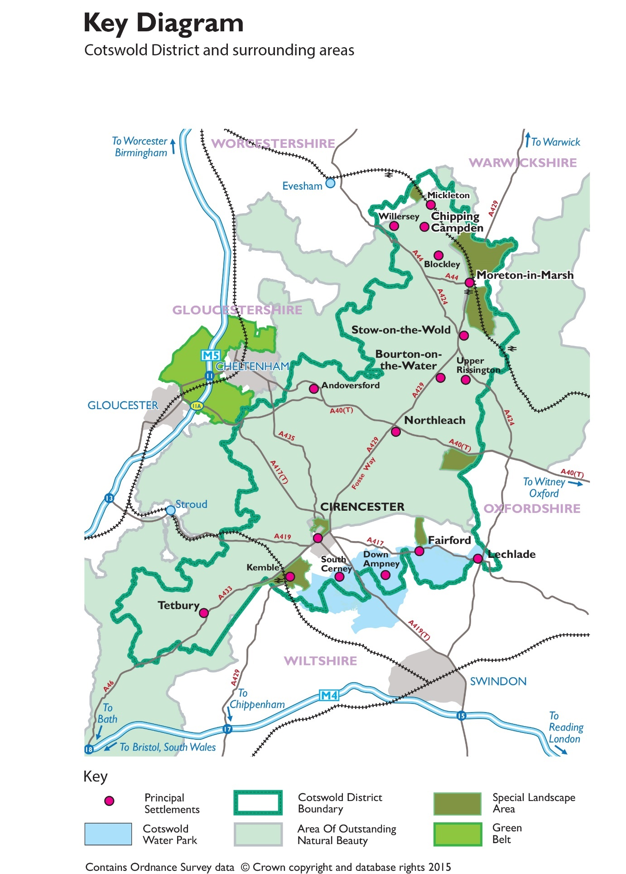
4.7 To deliver the development strategy and meet the objectively assessed housing and employment needs of the District 2011-2031 Policy DS1 includes the following development strategy:
4.8 The housing land requirement for Cotswold District is 8,400 dwellings 2011 to 2031. As of 1st April 2019 Cotswold District had a 5-year housing land supply of 7.6 years. To manage future development the Local Plan includes a set of development boundaries, within these boundaries development will be permissible in principle (Figure 7).
4.9 Policy S6 sets the strategic development plan policy for Kemble and should be read in conjunction with Inset Map 5 of the CDLP (Figure 5 in the KENDP). This policy allocates three sites for housing development and protects three Local Green Spaces in Kemble:
LGS5 – Green at West Lane
LGS6 – Community Gardens at Station Road
LGS 7 – Playing field at Clayfurlong

Figure 7. Cotswold District Local Plan, Kemble Inset 5
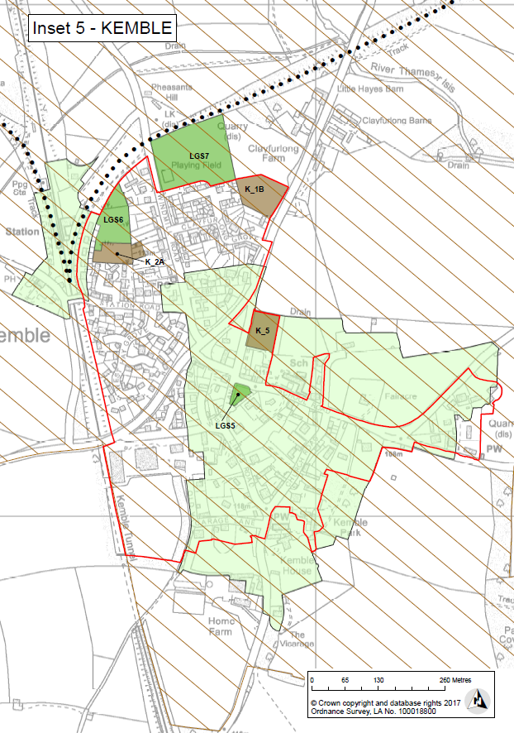
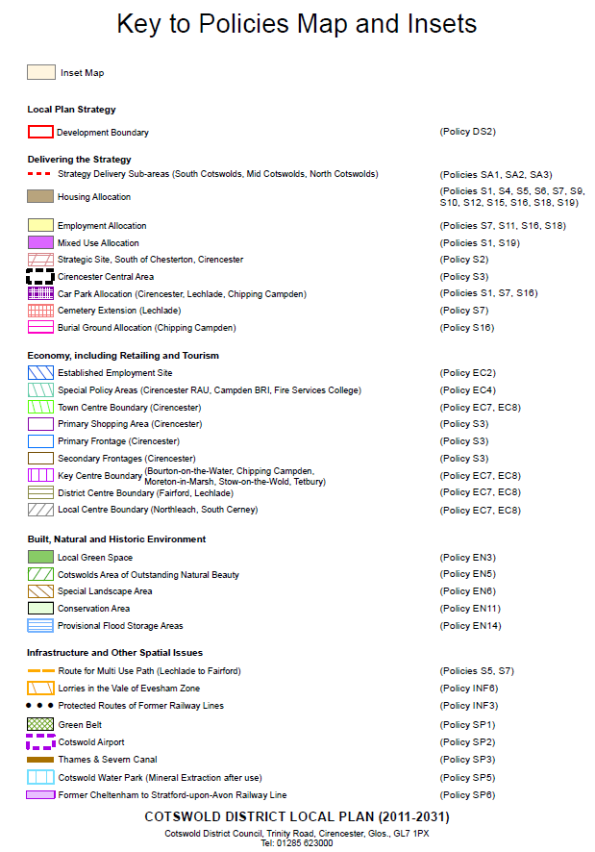
4.10 Ewen is a non-principal settlements and only small-scale residential development will be permitted in accordance with CDLP Policy DS3 when it:
4.11 Development outside of settlements will be “in accordance with other policies that expressly deal with residential development in such locations” (CDLP Policy DS4).
4.12 The CDLP also includes a number of strategic infrastructure measures for the South Cotswold Sub-Area. Policy SA1 identifies the following:
- SUDS and soft measure interventions to manage flood risk
- Junction improvements at A429/A433 between Cirencester and Kemble
- Re-use of former Cirencester to Kemble and Tetbury to Kemble railway lines for cycling
4.13 It should also be remembered that the CDLP also includes a number of Plan wide policies covering a number of issues e.g. Policy H1 sets policy for housing mix and tenure and Policy H2 sets policy for affordable housing:

5.0 Neighbourhood Plan Policies
5.1 This section of the KENDP sets out the planning policies to guide development in the Kemble and Ewen neighbourhood area up to 2031. The policies are set out below each of the KENDP objectives. Whilst the policies are sub-divided under the objectives the policies of the plan should and will be read as a whole and in the context of the Cotswold District Local Plan and the NPPF. The policies are also accompanied by a Policies Map, this shows any specific land allocations identified in the KENDP

OBJECTIVE 1 - To protect community facilities and ensure the villages have adequate infrastructure
Policy KE1 – Protection of Existing Community Facilities and Public Houses

The facilities listed below and shown on the Policies Map will be protected for community use.

KE1/1 - Kemble Village Hall
KE1/2 - All Saints Church
KE1/3 - Kemble Primary School
KE1/4 - Kemble Post Office and Stores
KE1/5 - The Tavern Inn
KE1/6 - Wild Duck Inn
KE1/7 - The doctors’ surgery in Kemble
KE1/8 - Kemble railway station

Development that would lead to the loss of these facilities will be permitted when it is in accordance with relevant development plan policies.

Proposals that would appropriately enhance these facilities or enhance the appearance of and/or improve access and accessibility to these facilities will be supported when they are in accordance with other development plan policies and the policies of the KENDP.

Background/Justification
5.2 Community facilities are the essential glue that help bind a community together. They provide important services, places for people to meet and interact contributing to individuals’ and the community’s health and well-being.
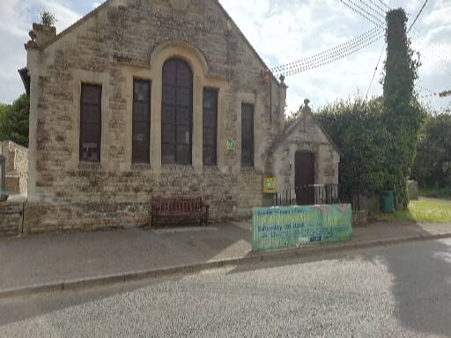
1 Kemble Village Hall
5.3 National planning policy acknowledges that the planning system can play an important role in facilitating social interaction and creating healthy, inclusive communities.
5.4 In line with national planning policy the KENDP identifies those community facilities that should be protected in the neighbourhood area. Kemble, based on its social and economic sustainability, was defined as one of 7 Principal Settlements in the South Cotswold Sub-Area in the CDLP. To maintain the sustainability of the area a variety of uses need to be retained, including access to local retail, places to meet and sustain essential aspects of village life.
5.5 Policy INF2 Social and Community Infrastructure of the CDLP sets out the circumstances when the loss of a community facility or service will be permitted. These are:
a. it is demonstrated that there is no local demand for the facility or service, or demand for an appropriate, alternative local community use for the facility; or
b. replacement facilities or services are provided in an appropriate alternative location having regard to the requirements of Clause 1 above.
Clause 1 of CDLP Policy INF2 sets out the principles for assessing new community facility proposals, including accessibility to the local community.

Policy KE2 - Infrastructure
Proposals to improve local infrastructure will be supported. In particular the community’s priorities for improvements are the following:
- Improvements to Kemble Village Hall
- Improved facilities at Kemble Playing Field
- Improvements to Kemble Primary School
- Sustainable re-use of the Tetbury/Cirencester to Kemble rail lines

Background/Justification
5.6 The CDLP proposes a number of strategic infrastructure improvements for the South Cotswolds Sub-Area including:
- SUDS (sustainable drainage systems) and soft measure interventions to manage flood risk
- Junction improvements at A429/A433 between Cirencester and Kemble
- Re-use of former Cirencester to Kemble and Tetbury to Kemble railway lines for cycling
Policy KE2 seeks to identify a set of detailed local infrastructure projects these could be implemented if required to make a particular development acceptable in planning terms, or if adopted in the programme of a suitable agency, such as the County Council or if funding is available to the Parish Council e.g. Community Infrastructure Levy.

OBJECTIVE 2 - To protect local green spaces

Policy KE3 Protecting Local Green Space

The following local green spaces as shown on the Policies Map are designated in accordance with paragraphs 99 and 100 of the NPPF:

KE3/1 – Paddock at the rear of Glebe Barn
KE3/2 - Field between Clayfurlong Farm and site KI_B
KE3/3 – Land opposite The Timbrells, Ewen
KE3/4 – Land off School Road, Kemble

Development will only be permitted when it accords with national and relevant Local Plan policies.

Background/Justification
5.7 Paragraph 99 of the National Planning Policy Framework (NPPF) advises that “local communities through local and Neighbourhood Development Plans should be able to identify for special protection green areas of particular importance to them. By designating land as Local Green Space communities will be able to rule out new development other than in very special circumstances”.
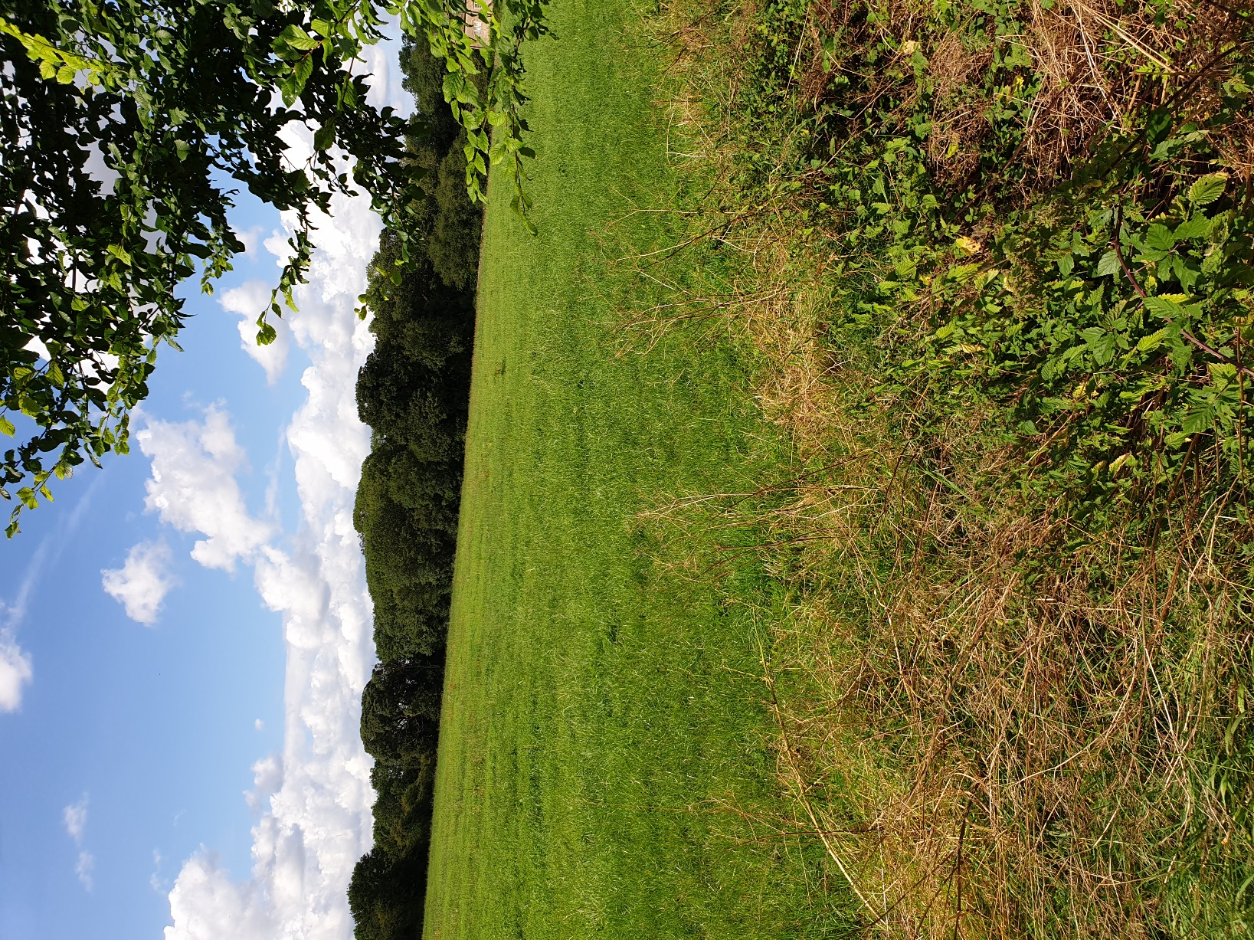
2 Clayfurlong Field
5.8 Paragraph 100 of the NPPF goes on to advise that “the Local Green Space designation will not be appropriate for most green areas or open space. The designation should only be used:
- where the green space is in reasonably close proximity to the community it serves;
- where the green area is demonstrably special to a local community and holds a particular local significance, for example because of its beauty, historic significance, recreational value (including as a playing field), tranquillity or richness of its wildlife; and
- where the green area concerned is local in character and is not an extensive tract of land.”
5.9 The CDLP designates three Local Green Spaces in Kemble. Through the KENDP three other Local Green Spaces are put forward for designation. Using the Green Space Designation Toolkit produced by Cotswold District Council this area is considered to meet the designation criteria set out in national planning policy (Appendix 3).

Policy KE4 Protecting Other Open Spaces

Development that would result in the loss of open spaces within the Kemble Village development boundary or Ewen village will be only supported when:

- Equivalent or better provision is provided elsewhere within a suitable location within the relevant village or in the case of Kemble within the village Development Boundary; or
- It can be clearly demonstrated by the applicant that the open space no longer performs a useful open space function in terms of the local environment, amenity of any kind, or active public recreation use.
.

Background/Justification

5.10 As well as the key green spaces that are as designated Local Green Spaces under Policy KE4, Kemble and Ewen also have several other important open spaces that perform a variety of useful functions, e.g. grass verges that add to the character of the area, provide a relief from built development and help to separate different land uses. These smaller open spaces help to make the area a greener place, preserve village character, add to visual amenity and all add to the quality of life enjoyed by residents and visitors. It is proposed that these spaces are also protected but not with the high degree of protection offered to designated local green spaces. These spaces may be appropriate for development in the circumstances set out in Policy KE4.

OBJECTIVE 3 - To retain the scale of the villages and help manage future change

Policy KE5 – New Development within the Kemble Development Boundary

Within the Kemble Development Boundary. as defined on CDLP Policies Map (Inset 5), development will be supported when it:

- is located on an infill site the resulting loss of which would not have a significant adverse impact on the character and appearance of the area and would not lead to a loss of rural character. Subdivision of existing site plots and back land development will be resisted except where clear benefits to the character and appearance of the settlement are demonstrated;
- is appropriate in scale (e.g. individual or small groups of houses) and relates well to the existing layout, facilities and amenities of the village;
- makes best use of previously developed land and existing buildings;
- meets the design policies set out in the CDLP and the KENDP and seeks so far as possible to enhance to character and appearance of the area;
- is capable of providing safe access for vehicles, pedestrians and cycles and includes off-street car parking to serve the development as required to meet locally adopted standards;
- does not have a significant adverse impact on the amenity of existing and future occupiers;
- has assessed and incorporated measures to maximise opportunities to walk, cycle and use public transport for those without access to a private vehicle; and
- it does not conflict with guidance in the Kemble Landscape Appraisal (Tyler Grange) and the Kemble and Kemble Station Conservation Area Appraisal (Montagu Evans).

Background/Justification
5.11 The CDLP defines a development boundary for Kemble village (Inset 5 in the CDLP, Figure 7 of the KENDP). This boundary includes most of the built form of Kemble village. Within this boundary development will be permissible in principle (CDLP Policy DS2).
5.12 Policy KE5 sets out more detailed local criteria against which planning proposals within the Kemble Development Boundary will be assessed. It should be noted that Policy KE5 should also be read in conjunction with the other policies in the KENDP, particularly those on design, and other development plan policies. Policy KE5 seeks to ensure that infill development retains the rural character of the village and does not lead to development that appears to be “could be anywhere” development or “suburban” in character. It is important that infill development does not result in “town cramming” with consequent suburbanisation of the village. There has been a significant amount of infill/backland development already with a loss of village character in some areas. It is important in these circumstances that future development is carefully controlled and that opportunities are taken for enhancement.
5.13 Ewen has no development boundary and no local services beyond the Wild Duck Inn. It is not a sustainable location for new development. Applications for new development will be determined in accordance with relevant Local Plan policies.
5.14 To help all residents to minimise their use of private vehicles and to walk and cycle more and make more journeys by public transport, proposals should seek to include measures to increase the use of these more sustainable transport modes in line with the County’s Local Transport Plan and Connecting Places Strategy.

OBJECTIVE 4 – To improve access to the countryside for informal recreation

Policy KE6 – Green Infrastructure

The network of Green Infrastructure (GI) within the neighbourhood plan area will be protected for its recreation, open space and wildlife value. New GI, particularly where it creates links to the existing GI network and improves access to the countryside for informal recreation and net gains in biodiversity will be supported.

Development will only be permitted where it retains/protects/enhances the recreational, biodiversity, water management and other functions of the GI network.

New development should enhance linkages to the wider existing GI network and improve access to the countryside for informal recreation, where appropriate.

Background/Justification

5.14 Green Infrastructure (GI) is the network of parks, open spaces, playing fields, woodlands, allotments and private gardens in an area. The neighbourhood area’s GI includes existing links from the villages to the wider countryside; features such as Kemble Wood; and the nationally important Thames Trail that links to the source of the Thames/Isis. This network of GI will be protected and, where opportunities arise, new GI should be created that, where feasible, should link in to the existing GI network. New links should seek to create increased access to the surrounding countryside for informal recreation (e.g. walking, cycling and horse riding), and, through the use of native species appropriate to the area, should seek to produce net gains in biodiversity.
5.15 The KENDP does not contain specific policies related to ecology because there is currently a comprehensive suite of ecology policies in the Local Plan (Polices EN7, 8 and 9). The currently identified sites of ecological interest in the NDP area are shown on the Map in Appendix 2. They are:
- Kemble Railway Cuttings SSSI
- Kemble Wood Local Wildlife Site and Ancient Woodland
- Limekiln Hill, Conservation Road Verge.

OBJECTIVE 5 -To retain the identity and character of the villages

Policy KE7 – Kemble and Ewen Design Guide

Development that is consistent with the other policies in this neighbourhood development plan and the Cotswold District Local Plan will be supported when they accord with the Kemble and Ewen Design Guide.

The Kemble housing sites identified in the CDLP are subject to the detailed guidance set out below:

K1_B – Land between Clayfurlong Grove and A429

This site on the northern edge of the village should be designed to

- provide an organic extension to the village, this will require careful use of materials, building styles and sizes, siting, layout and high-quality boundary treatments;
- produce an extension to the village that enhances the character of the area and avoids a standard house-type, suburban character type development;
- create a new edge to the village, in what is currently an open field, that is of high quality and minimises the intrusion of the development into the local landscape. This should be done by using a mix of stone and native tree and hedge species;
- pay particular regard to the siting of individual dwellings so that the dwellings face the A429 and avoid exposing rear gardens on the site’s northern boundary;
- maximise opportunities to access the nearby bus stop, Kemble village and the recreation ground; and
- take particular care to not having a negative impact on the setting of the listed buildings at Clayfurlong Farm.

K_2A – Land at Station Road

Development proposals for the site should:

- prior to planning approval and development taking place, provide further assessment and evaluation of archaeology and biodiversity (including particularly herpetology);
- take account of the positive contribution the Local Green Space makes to the character of the wider site, including mitigating any potential impacts on natural features such as trees;
- be carefully proportioned; new buildings should not dominate their surroundings;
- complement the existing landscape and sit comfortably within the setting of the Local Green Space. The height of buildings should provide a gentle transition from the open Local Green Space to the existing dwellings that border the site;
- investigate opportunities to locate a Sustainable Drainage System, in accordance with relevant Local Plan policies, in the south-western part of the site; and
- provide safe, legible access to the Local Green Space through the site.

K_5 – Land to north west of Kemble Primary School

This site is within Kemble Conservation Area, development proposals should:

- provide a strong frontage to West Lane and a strong boundary treatment, similar to existing stone walls in this part of the village;
- recognise the site is relatively self-contained, proposals should retain this sense of containment by retaining existing trees where appropriate and by supplementing these with new native planting; and
- the overall development should be designed to create an organic extension to the village, this will require careful use of materials, building styles, sizes, siting and layout. A standard house-type, suburban estate character development will not be supported.

Background/Justification
5.15 Kemble and Ewen have distinct characters and identities and many buildings and spaces of high-quality. It is important to ensure that future development helps to retain these strong characters and identities. The NPPF and the National Design Guide place a considerable emphasis on achieving well designed places (section 12).To ensure that new development is of good design that creates the high-quality buildings and places sought through national planning policy (NPPF particularly paragraph 124) it should meet the requirements of the Kemble and Ewen Design Guide, which is a part of the KENDP and is available as a separate accompanying document.
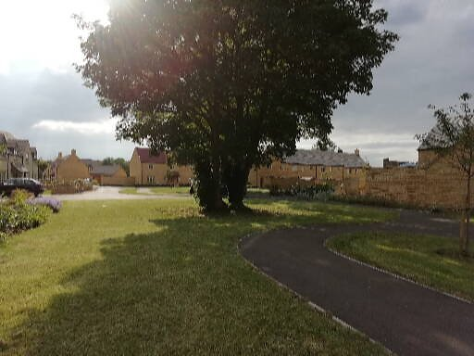
3 Recent development at Top Farm
5.16 Design Codes or Guides provide a set of illustrated design requirements that provide specific, detailed parameters for the physical development of a site or area. With the help of consultants AECOM, Kemble and Ewen have prepared such a Design Guide. All development should accord with this Guide. In addition, proposals should also accord with the Cotswold Design Code - https://www.cotswold.gov.uk/media/1621472/appendix-d-cotswold-design-code.pdf
5.17 Policy KE7 also sets out more detailed design considerations, based on the General Design Guidelines in the Kemble and Ewen Design Guide. Development of these sites should be in accordance with this detailed guidance.

Policy KE8– Kemble and Kemble Station Conservation Area

Within Kemble and Kemble Station Conservation Areas (Figure 8) and their settings new development should preserve or enhance the character and appearance of the Conservation Areas and their settings. In particular:

- New buildings or extensions should reflect the general pattern of building within the area, especially in scale, form, proportion and detailing, although there may be scope for some architectural invention provided that this is sympathetic to the existing architecture of the place;
- Materials should normally be those traditionally used in that particular part of the Conservation Area, and should maintain a similar mix. Extensions to buildings should use materials that are sympathetic to the existing building. Where possible and feasible materials and construction should be sustainable to help reduce carbon emissions;
- Extensions should normally have a subordinate scale and be positioned away from main elevations and unobtrusively, mindful of the character and appearance of the area and views from publicly accessible areas and for other parts of the conservation area;
- Boundary walls, railings and hedges should be incorporated in the development in a similar way to those already in existence in that part of the Conservation Area, and these should use similar materials and detailing, or species;
- Important views and vistas within and of the Conservation Area should be maintained. These include, but are not limited to:

- The views from footpath BKE 8/1 north east towards Kemble Village
- The view from Washpool Lane on the boundary of Kemble Park, facing south-west, towards Kemble House.

These views are shown at page 10 of the Kemble Landscape Appraisal: Tyler Grange (2017)

- In the implementation of this policy and in particular in considering which areas are of particular importance regard will be had to the Kemble and Kemble Station Conservation Areas Appraisal and Management Guidance report prepared by Montagu Evans.

Background/Justification
5.18 Kemble Conservation Area was designated on 17 February 1981. The boundary was reviewed and extended on 25 September 1990 and comprises an area that straddles the A429. To the south-east, the older part of the village includes a range of buildings from traditional Cotswold stone cottages along West Lane and Church Road to Victorian properties on Limes Road and School Road and All Saints Church, a landmark building of great importance. The part to the Conservation Area north of the A429 is centred on Biddulph Cottages and is prominent from the road. The Kemble Conservation Area includes 14 listed buildings. The Kemble Station Conservation Area was designated on the 20th November 1990 and is centred on the railway station and the associated cottages.
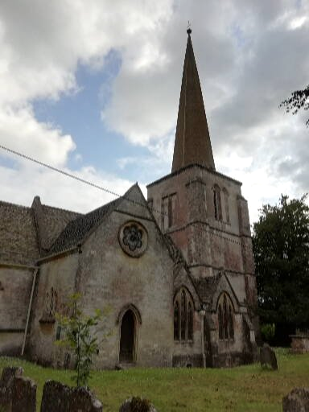
4 All Saints Church, Kemble
5.19 The Conservation Areas, as designated heritage assets, already have statutory protection. Policy KE8 does not replace this statutory protection that already places limits on the type of development that can take place e.g. demolition of a building. Conservation Area status means that the significance of such areas should be preserved or enhanced. Policy KE8 seeks to provide additional guidance and sets out the key features of the Conservation Areas that should be considered when particular types of development are proposed. Policy KE8 should be read in conjunction with the other design and landscape policies of the KENDP and the Kemble and Kemble Station Conservation Areas Appraisal and Management Guidance prepared by Montagu Evans.
5.20 The two views identified in Policy KE8 were identified in the Kemble and Kemble Station Conservation Areas Appraisal and Management Guidance as contributing to the setting and significance of Kemble Conservation Area. The view from footpath BKE8/1 south west of the village provides a view to the north east with the spire of All Saints Church visible on the horizon. This is an attractive view of a typical Cotswold village over an area of open land deliberately preserved free of intrusion by the railway line. This area has historical value in that it spans Kemble Tunnel and is the result of Robert Gordon’s successful attempt to retain this area as open land. In the background of this view is the designed landscape associated with Kemble House. The second view to be protected, that from Washpool Lane, offers glimpses of Kemble House and All Saints Church and includes the view over the designed landscape associated with Kemble House.
Figure 8. Kemble and Kemble Station Conservation Areas
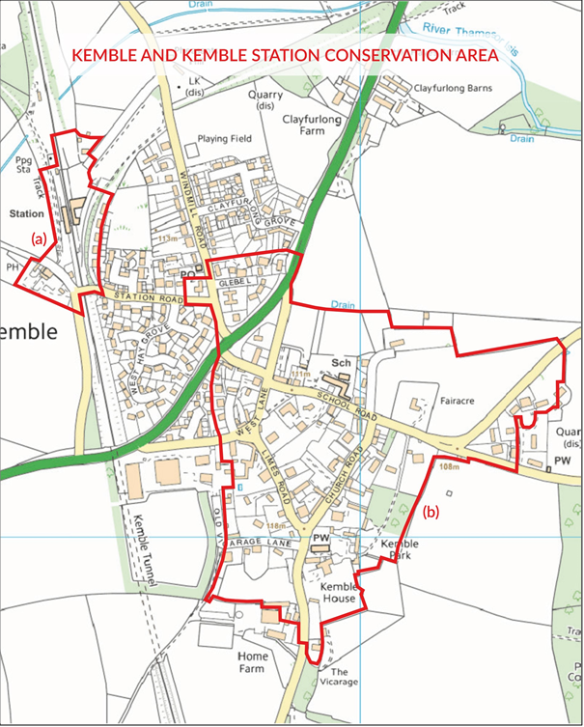
Parish Council Supporting Action
The boundaries of the Conservation Area do not include the following notable buildings or elements of setting:
• The historic primitive Methodist Chapel on Washpool Lane;
• The historic parkland landscape associate with Kemble House; or
• The open land around and covering the railway tunnel to the south-west of the village which is important in the setting of the Conservation Area and views of the village including the Grade 2* All Saints Church.
• The local authority should consider using planning powers to ensure historic walls are preserved and maintained in good condition
These elements are all historically significant features of the village, and make a valuable contribution to its special interest. The Parish Council will work with CDC to review the Conservation Area boundaries with a view to extending them in the locations set out above.

Policy KE9– Development affecting non-designated heritage assets

Development affecting non-designated heritage assets will be assessed in accordance with relevant Local Plan policies and national planning policies:

The KENDP identifies the following non-designated heritage assets:

KE9/1 - Kemble School
KE9/2 - Kemble Village Hall
KE9/3 - Primitive Methodist Chapel
KE9/4 - The water pump and stone surround on the Kemble village green
KE9/5 - The old school house at Ewen
KE9/6 – The historic parkland associated with Kemble House
KE9/7 – The open land around and covering the railway tunnel to the south-west of the village which is important in the setting of the Conservation Area and views of the village including the Grade 2* All Saints Church.

This is not an exhaustive list. Further non-designated heritage assets may be added in the future.

Background/Justification
5.21 As well as designated heritage assets, such as Listed Buildings, that already have statutory protection through existing legislation, the neighbourhood plan area includes several other buildings and structures that have heritage value. In “planning speak” these are termed non-designated heritage assets. These assets are links and reminders of the area’s long and varied history, for example there are assets linked to the area’s agricultural and railway history. Whilst in some parts of the country there are local lists of non-designated heritage assets, in Cotswold District a comprehensive list is not available. National planning policy is set so that heritage assets should be conserved in accordance with their significance. Policy KE9 identifies the neighbourhood area’s non-designated heritage assets. These non-designated heritage assets will be subject to the provisions in CDLP Policy EN12: Historic Environment: Non-Designated Heritage Assets.
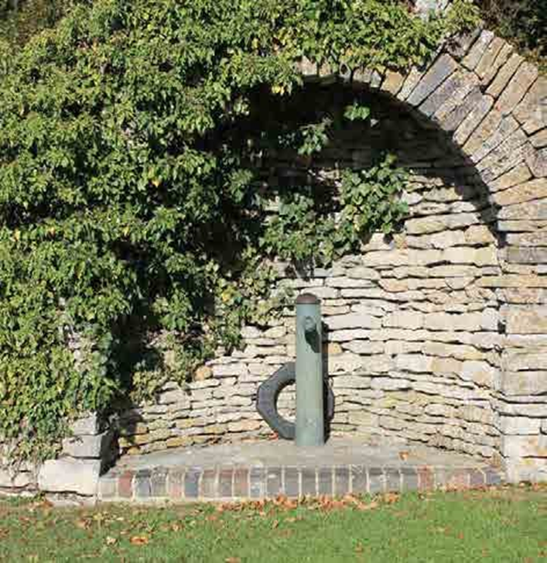
5 Village pump and surround (Source: Kemble Landscape Appraisal. Photo credit: Anne Wilton)
5.22 The non-designated heritage assets have been identified using the criteria set out in Table 6 of the CDLP.

Policy KE10 – Archaeology

Any future proposals for development within and around Kemble and Ewen villages should be accompanied by a thorough assessment of the potential effects on archaeological heritage assets in accordance with guidelines issued by the Chartered Institute for Archaeologists and in accordance with a brief approved by the Historic Environment Service of Gloucestershire County Council. This work must be carried out prior to the submission of any planning application.

Where possible, and appropriate, development proposals should seek to incorporate archaeology in such a way that any conserved remains can be accessed by the public and that suitable signage and information is provided to and on the site to promote such access and aid interpretation of the asset.

Background/Justification
5.23 The neighbourhood area contains significant archaeological remains. The Kemble Heritage Appraisal 2017 noted that:
“In summary the archaeological potential of Kemble and its rural surroundings can be regarded as high. Therefore, any future proposals for development within and around the village should consult the Historic Environment Record and where potential exists for archaeological remains planning proposals should be accompanied by a thorough assessment of the potential effects on such heritage assets in accordance with guidelines issued by the Chartered Institute for Archaeologists and in accordance with a brief approved by the Historic Environment Service of Gloucestershire County Council. This work must be carried out prior to the submission of any planning application and, in this regard, must satisfy paragraph 189 of the National Planning Policy Framework and Policies EN1 and EN12 of the CDLP.”

Policy KE11 –Landscape
- Within the Special Landscape Area (as defined on the Cotswold District Local Plan Policies Map) development will be supported provided it does not have a significant detrimental impact upon the special character and key landscape qualities of this area including its tranquillity.

- In the wider landscape proposals should:

- Retain and where possible enhance those landscape assets which are of benefit to the quiet enjoyment of the rural landscape by residents and the community. In identifying such areas regard will be had to the Kemble Landscape Appraisal undertaken by Tyler Grange;
- Maintain the physical and visual separation between Kemble and Ewen to retain the sense of identity of the distinct settlements;
- Reinforce the Thames valley landscape in respect of its recreational value and visual amenity creating a quiet and tranquil valued rural landscape;
- Maintain and enhance field pattern and enclosure where possible;
- Enhance landscape features which are in decline or in poor condition;
- Avoid further erosion of the landscape/farmed edge of the villages;
- Protect views and vistas identified in the Kemble Landscape Appraisal and the Kemble and Kemble Station Conservation Areas Appraisal undertaken by Montagu Evans; and
- Retain areas of woodland, tree belts and hedges.

Background/Justification

5.24 The landscape around Kemble and Ewen has been subject to a comprehensive and up to date assessment by Tyler Grange (Figure 9). The policy seeks to ensure that the landscape assets and views around the village are appropriately protected and where possible enhanced. In addition, the CDLP identifies part of the neighbourhood area as a Special Landscape Area. Within this area Policy EN6 of the CDLP sets out that:

“Development within Special Landscape Areas (as shown on the Policies Map) will be permitted provided it does not have a significant detrimental impact upon the special character and key landscape qualities of the area including its tranquillity.”

5.25 Policy KE11 supports this strategic planning policy and sets more detailed criteria against which planning proposals will be assessed. Applicants should, therefore, pay particular regard to Policy KE11.
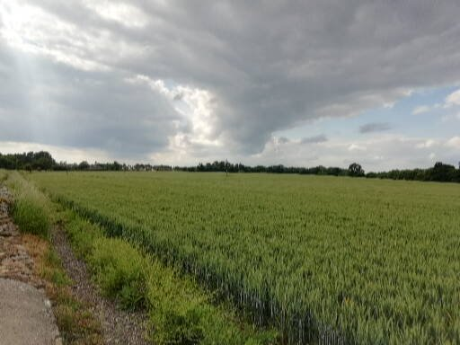
6 View north west from Parker’s Bridge across the Special Landscape Area towards Kemble

Figure 9. Landscape Planning Policy (Source: Kemble Landscape Appraisal, Tyler Grange, 2017)

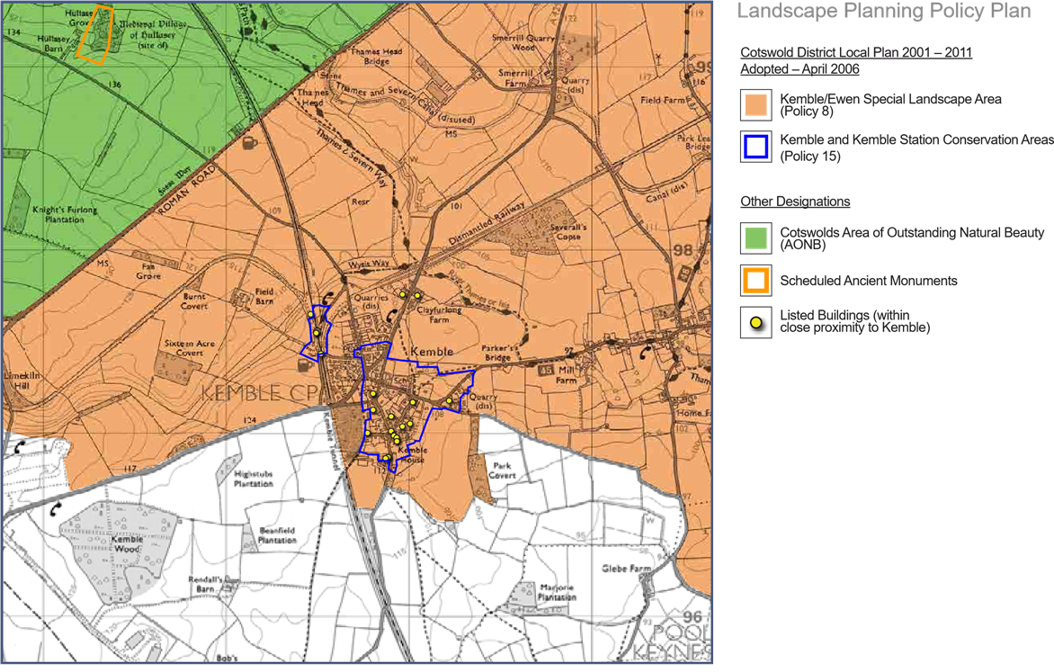

Policy KE12 – Cotswold Airport

- Changes of use and new development at Cotswold Airport within the areas covered by the KENDP will be permitted when consistent with Cotswold District Local Plan Policy SP2 and providing impact on residential amenity and the local environment is met when assessed against the following:

  - Impact on the local community and others, including by way of noise, visual amenity, traffic generation. odours and air pollution; and
  - Impact on designated natural and built environment assets, the AONB and the local landscape.

- To reduce traffic impacts and promote sustainable development all development proposals should be supported by a travel plan to seek, so far as possible, that movements by private car are reduced.

- Where negative impacts are identified after assessing proposals in relation to Policy KE12 these should be mitigated. Where negative impacts cannot be satisfactorily mitigated planning permission should be refused.

Background/Justification
5.26 Policy SP2 “Cotswold Airport” of the of the CDC Local Plan supports the continued use of Kemble Airfield for employment purposes (Local Plan Inset 19). Policy SP2 allows changes of use and new development provided that they are compatible with the use of the land as an airport.
5.27 The KENDP supports the ongoing use of the airfield for employment purposes but these should protect the local environment and amenity. Currently some of the employment uses have undesirable and harmful impacts particularly in terms of lighting and visual amenity. Changes of use and any new development should be managed and controlled to prevent these and other negative impacts occurring and, where possible, to mitigate or remove existing impacts. The KENDP Policy KE12 seeks to ensure that potential impacts are assessed as part of the development management process. Where such impacts are identified they should be mitigated in such a way to reduce to a minimum impact on residential amenity and the local environment. In the absence of effective mitigation, planning permission will be refused.


7 Cotswold Airport (Source: http://www.cotswoldairport.com/gallery/general)
Supporting Parish Council Action
The KENDP cannot, and does not seek to, address the control of aviation activity but the Parish Council will seek through continued and constructive cooperation with Cotswold Airport to minimise the impacts of aviation and other aspects of the airport site use on the surrounding communities.
6.0 How to comment on this document

6.1 The Kemble and Ewen Draft Neighbourhood Plan has been published for consultation [dates to be inserted]. Comments can be returned by:

[to be inserted by CDC].

6.2 After this formal submission consultation the KENDP will be the subject of an Independent Examination by a jointly appointed Examiner, to consider whether the Plan meets the basic conditions and any legal requirements.

6.3 If the KENDP is considered to meet these requirements, the examiner will recommend that the KENDP proceeds to a local Referendum. In this vote, a straight majority (50% of turnout +1) of those on the Electoral Register will be required to approve the KENDP. CDC will then “make” the Plan part of the development plan for the area. The KENDP will then be used to help determine planning decisions in the Kemble and Ewen neighbourhood area alongside CDC and National Planning Policies.

Appendix 1. Local Green Spaces

1 |  | General Information | Tick if relevant evidence provided
1.1 |  | Name and address of site  KE3/1, Paddock at the rear of Glebe Barn
1.2 |  | Site location plan
Insert here or attach separately
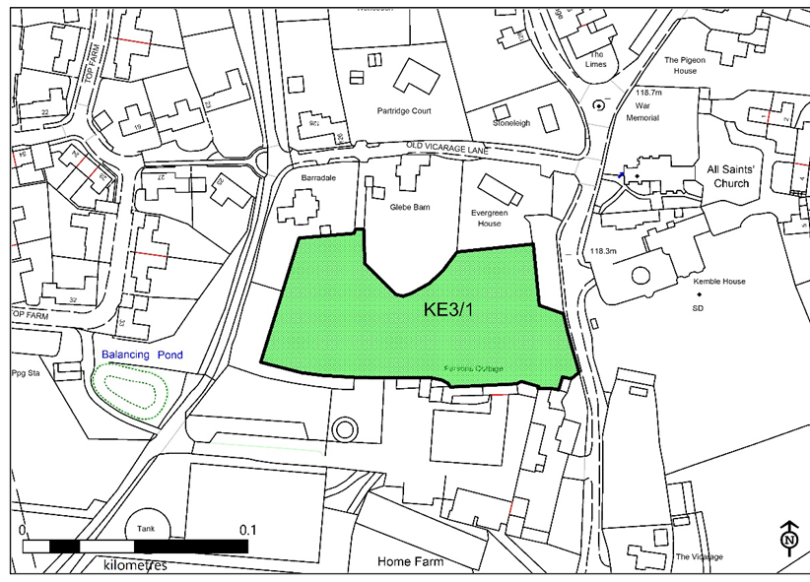

1.3 |  | Organisation or individual proposing site for designation  Kemble and Ewen Parish Council
1.4 |  | Ownership of site if known  Not known.  Information on land ownership can be obtained from the Land Registry. Some land parcels are not registered however local people may know the owner.
1.5 |  | Is the owner of the site aware of the potential designation? Do they support the designation?  The site has been included in the draft NDP which has been widely consulted on.
1.6 |  | Photographs of site
Insert here or attach separately
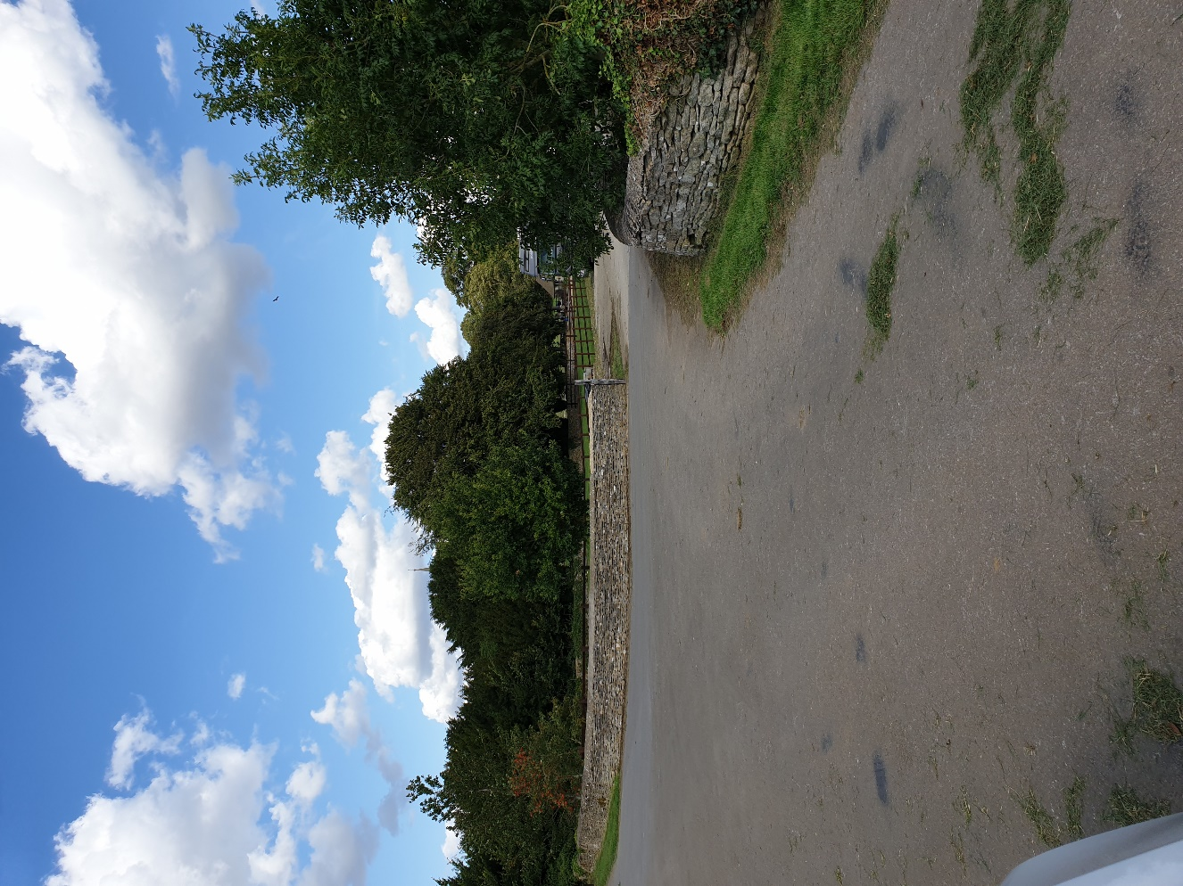

1.7 |  | Community served by the potential Local Green Space  The site serves the whole community in the sense that it is important for heritage and landscape reasons. It is within the Kemble Conservation Area and in close proximity to an important group of listed buildings. Views over the site to the village and the church from Kemble Footpath 8 are important as designed views preserved when the railway was constructed. These are referred to in the Montagu Evans Conservation Area Appraisal.  i.e. does the site serve the whole village/town or a particular geographic area or group of people?
2 |  | Planning History
2.1 |  | Is there currently a planning application for this site?  No.
 |  | Further Information – Cotswold District Council – planning applications
2.2 |  | Is the site allocated for development in the Local or Neighbourhood Plan? If allocated, could part of the overall site still be used as a Green Open Space? No.  Further Information – Cotswold District Council – planning policy.
 |  | To be designated local green space in the neighbourhood plan.
3 |  | Size, scale and “local nature” of proposed Local Green Space
3.1 |  | Area of proposed site  0.68 hectares
3.2 |  | Is the site an “extensive tract of land”?  No. The site is a well contained area with the village.
3.3 |  | Is the proposed site “local in character”?  Yes. See above. The site is in the Conservation Area and relates very closely to the buildings and the area around it.
4 |  | Need for Local Green Space
4.1 |  | Is there a need for a local green space in this location?  The site is not designated to meet any need for accessible space for recreation. It is designated for its heritage and landscape importance as set out above. It needs to be preserved in order to preserve the landscape and heritage values evident in this part of the village and the views into it.
5 |  | Evidence to show that “the green space is in reasonably close proximity to the community it serves”  Please indicate what evidence you have provided against each point.
5.1 |  | How far is the site from the community it serves?  Is the site within 2km of the local community?  The site is within the community it serves and the Conservation Area.
5.2 |  | Are there any barriers to the local community accessing the site from their homes?  The site is not publicly accessible. Its value lies in its current open and undeveloped state and the contribution it makes to bot heritage and landscape interests.
6 |  | Evidence to show that the green area is “demonstrably special to a local community”  Please indicate what evidence you have provided against each point.
6.1 |  | Evidence of support from Parish or Town Council e.g.  The Parish Council is promoting the NDP and supports the designation.
6.2 |  | Evidence of support from other local community groups or individuals.  The site was supported in the context on the community wide consultation on the NDP. No objections to its designation were raised.
6.3 |  | Evidence of support from community leaders  The Parish Council supports the proposal. No objection has been received from the ward member.
6.4 |  | Evidence of support from other groups
7 |  | Evidence to show that the green area “holds a particular local significance, for example because of its beauty,” (if applicable) Please indicate what evidence you have provided against each point.
7.1 |  | Is this criteria relevant to this site?
 |  | YES
7.2 |  | Describe why the community feels that the site has a particular local significance for its beauty.
 |  | The site is important in views into the village from the adjacent area and in particular Kemble Footpath Number 8. It is part of a composition that allows views of the historic core of the village and the church from the approach to the village. It is quintessentially English from the countryside to the church and the heart of the village.
7.3 |  | Site visibility  e.g. is it easy to see the site from a public place? Are there long-distance views of the site? Are there views of the site from any key locations?
 |  | See above. The site is important in the key views referred to.
7.4 |  | Is the site covered by any landscape or similar designations?  e.g. Area of Outstanding Natural Beauty; Conservation Area; Special  Landscape Area
 |  | The site is within the CDC LP EN6 Kemble Special Landscape Area and with the Kemble Conservation Area.
7.5 | Is the site (or the type of site) specifically mentioned in any relevant landscape character assessments or similar documents?  e.g. Cotswolds AONB landscape character assessment. Further information – Cotswold District Council; Natural England; Cotswolds Conservation Board
 | The site is within the Historic Core are identified in the Tyler Grange Kemble Landscape Appraisal and with an important area identified in the Montagu Evans Kemble Conservation Area Appraisal.
7.6 | Does the site contribute to the setting of a historic building or other special feature?
 | Yes, it contributes strongly to the setting of the Grade 2* All Saints Church and to the significant group of listed buildings in the core of the village including Kemble House, Home Farm and Barn and the war memorial.
7.7 | Is the site highlighted in literature or art?  e.g. is the site mentioned in a well-known poem or shown in a famous painting?
 | No.
8 | Evidence to show that the green area “holds a particular local significance for example because of its historic significance” (if applicable)  Please indicate what evidence you have provided against each point.
8.1 | Is this criteria relevant to this site?
 | YES
8.2 | Are there any historic buildings or remains on the site?  e.g. listed buildings; scheduled ancient monuments; registered parks and gardens; war memorials; other historic remains or structures. Further information – Cotswold District Council; English Heritage;  Gloucestershire Historic Environment Record; Gloucestershire Archives; local history society;
 | None on the site but all around it.
8.3 | Are there any important historic landscape features on the site?  e.g. old hedgerows; ancient trees; historic ponds or historic garden features  Further information – Cotswold District Council; English Heritage;  Gloucestershire Historic Environment Record; local history society
 | Yes, the site is part bounded by the wall of the Old Vicarage.
8.4 | Did the site play an important role in the historic development of the village or town?  e.g. the old site of the town railway station; the old garden for the manor house etc.
 | Yes. See above for the role of the site in the preserved and designed views of the village when the railway was built.
8.5 | Did any important historic events take place on the site?
 | Not known.
8.6 | Do any historic rituals take place on the site? e.g. well-dressing; maypole dancing etc.
 | No.
9 |  | Evidence to show that the green area “holds a particular local significance, for example because of its recreational value  (including as a playing field)”, (if applicable)  Please indicate what evidence you have provided against each point.
9.1 |  | Is this criteria relevant to this site?
 |  | NO
9.2 |  | Is the site used for playing sport?  If so what sport? How long has it been used for sports provision? Is this sports provision free or is a club membership required? Further information – Sport England
9.3 |  | Are the public able to physically access the site?  e.g. are there any public rights of way across the site? Or adjacent to the site? Has access been allowed on a discretionary basis? Is there public access to the whole site or only part? Is there good disabled access to the site? (A site can still be designated even if there is no public access.)  Further information – Gloucestershire County Council
9.4 |  | Is the site used by the local community for informal recreation? And since when?  e.g. dog walking; sledging; ball games etc
10 |  | Evidence to show that the green area “holds a particular local significance, for example because of its tranquillity” (if applicable) Please indicate what evidence you have provided against each point.
10.1 |  | Is this criteria relevant to this site?
 |  | YES
10.2 |  | Do you consider the site to be tranquil?  e.g. are there are any roads or busy areas close by?
 |  | Yes.
10.3 |  | Is the site within a recognised tranquil area?  e.g. within the Campaign to Protect Rural England’s tranquillity maps
 |  | No.
11 |  | Evidence to show that the green area “holds a particular local significance, for example because of the richness of its wildlife”; (if applicable)  Please indicate what evidence you have provided against each point.
11.1 |  | Is this criteria relevant to this site?
 |  | NO
11.2 |  | Is the site formally designated for its wildlife value?  e.g. as a site of special scientific interest; a key wildlife site etc  Further information - Natural England; Gloucestershire Centre for Environmental Records
11.3 |  | Are any important habitats or species found on the site?  e.g. habitats and species listed in the UK priority habitats and species lists or in the Cotswold Water Park or Gloucestershire Biodiversity Action Plans or protected species or on the red/amber lists of birds of conservation concern.  Further information - Natural England; Gloucestershire Centre for  Environmental Records; National Biodiversity Network; Cotswold Water Park Trust; RSPB
11.4 |  | What other wildlife of interest has been found on the site?  Further information - Natural England; Gloucestershire Centre for  Environmental Records; National Biodiversity Network; Cotswold Water Park Trust
11.5 |  | Is the site part of a long-term study of wildlife by members of the local community?  e.g. long-term monitoring of breeding birds.
12 |  | Evidence to show that the green area “holds a particular local significance, for any other reason”; (if applicable)  Please indicate what evidence you have provided against each point.
12.1 |  | Is this criteria relevant to this site?
 |  | YES
12.2 |  | Are there any other reasons why the site has a particular local significance for the local community?
 |  | It is of particular significance because of the combination of the factors referred to above.

1 | General Information |  |  | Tick if relevant evidence provided
1.1 | Name and address of site  KE3/2, Field between Clayfurlong Farm and site KI_B
1.2 | Site location plan
 | 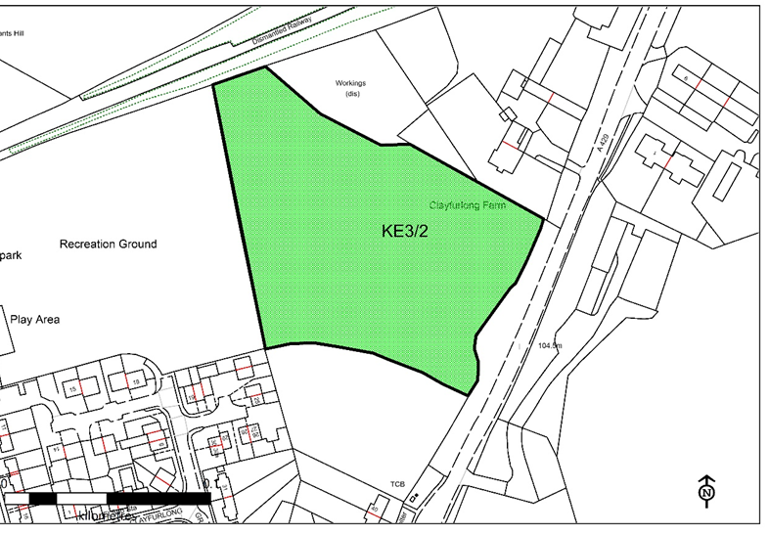Insert here or attach separately
1.3 | Organisation or individual proposing site for designation  Kemble and Ewen Parish Council
1.4 | Ownership of site if known  Information on land ownership can be obtained from the Land Registry. Some land parcels are not registered however local people may know the owner.
 | Not known.
1.5 | Is the owner of the site aware of the potential designation? Do they support the designation? (Sites may be designated as Local Green  Spaces, even if there are objections from the site owners)
 | Not known.
1.6 | Photographs of site
Insert here or attach separately
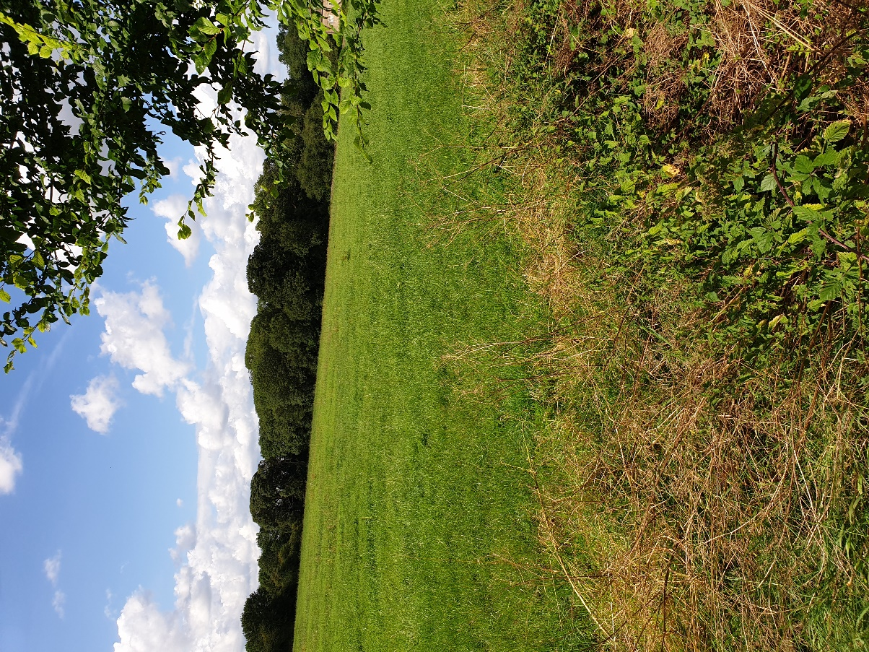

1.7 | Community served by the potential Local Green Space  i.e. does the site serve the whole village/town or a particular geographic area or group of people?
 | Yes, the site is a valuable component in both landscape and heritage terms. It serves the whole community.
2 | Planning History
2.1 | Is there currently a planning application for this site? If permitted/allocated, could part of the overall site still be used as a Green Open Space?
 |  | Further Information – Cotswold District Council – planning applications
 |  | No.
2.2 |  | Is the site allocated for development in the Local or Neighbourhood Plan? If allocated, could part of the overall site still be used as a Green Open Space?  Further Information – Cotswold District Council – planning policy.
 |  | To be designated local green space in the neighbourhood plan.
3 |  | Size, scale and “local nature” of proposed Local Green Space
3.1 |  | Area of proposed site  1.44 hectares
3.2 |  | Is the site an “extensive tract of land”?  (Extensive tracts of land cannot be designated as Local Green Space)  e.g. how large is it in comparison to other fields; groups of fields; areas of land in the vicinity etc.? Does the site “feel” extensive or more local in scale?
 |  | No.
3.3 |  | Is the proposed site “local in character”?  e.g. does the site feel as though it is part of the local area? And why?  How does it connect physically, visually and socially to the local area? What is your evidence?
 |  | Yes, it lies on the edge of the village.
4 |  | Need for Local Green Space
4.1 |  | Is there a need for a local green space in this location?  e.g. is there a shortage of accessible greenspace in the area? Is there a village needs survey or parish plan that provides evidence of that need. Further information – Natural England (Accessible Natural Greenspace Standard)  Cotswold District Council - Open Spaces, Sport and Recreation Study
 |  | The site is not being designated for accessibility reasons, but it is needed for the reasons referred to above
5 |  | Evidence to show that “the green space is in reasonably close proximity to the community it serves”  Please indicate what evidence you have provided against each point.
5.1 |  | How far is the site from the community it serves?  Is the site within 2km of the local community?  Possible evidence – a map to show that distance
 |  | The site immediately abuts the community it serves.
5.2 |  | Are there any barriers to the local community accessing the site from their homes?  e.g. railway line; main road  Possible evidence – a map to show any potential barriers and how those can be overcome.
 |  | The site is not publicly accessible, but it is a very visible component on the entrance to the village and from within it.
6 |  | Evidence to show that the green area is “demonstrably special to a local community”  Please indicate what evidence you have provided against each point.
6.1 |  | Evidence of support from Parish or Town Council e.g. letter of support; Council minutes
 |  | The Parish Council is promoting the NDP and supports the designation.
6.2 |  | Evidence of support from other local community groups or individuals. e.g. letters of support; petitions; surveys etc.
6.3 |  | Evidence of support from community leaders  e.g. letters of support from Ward Members; County Councillors; MP etc.  Further information on contact details - Cotswold District Council,  Gloucestershire County Council, House of Commons
6.4 |  | Evidence of support from other groups  e.g. letters of support from organisations such as Campaign to Protect Rural England; Cotswolds Conservation Board; Gloucestershire Wildlife Trust; Gloucestershire Rural Community Council; Cotswold Water Park Trust; local amenity societies; local schools etc.
7 |  | Evidence to show that the green area “holds a particular local significance, for example because of its beauty,” (if applicable) Please indicate what evidence you have provided against each point.
7.1 |  | Is this criteria relevant to this site?
 |  | YES
7.2 |  | Describe why the community feels that the site has a particular local significance for its beauty.
 |  | It is an important open element on the entrance to the village and provides an important break between Clayfurlong Farm and the village.
7.3 |  | Site visibility  e.g. is it easy to see the site from a public place? Are there long-distance views of the site? Are there views of the site from any key locations?
 |  | The site is highly visible from the main road and from within the village.
7.4 |  | Is the site covered by any landscape or similar designations?  e.g. Area of Outstanding Natural Beauty; Conservation Area; Special  Landscape Area  Further information – Cotswold District Council; Natural England; Cotswolds Conservation Board
 |  | The site lies within the Kemble Special Landscape Area designated in the CDC LP policy EN6.
7.5 |  | Is the site (or the type of site) specifically mentioned in any relevant landscape character assessments or similar documents?  e.g. Cotswolds AONB landscape character assessment. Further information – Cotswold District Council; Natural England; Cotswolds Conservation Board
 |  | The site is identified as part of the “Small scale farmland area” in the Tyler Grange Landscape Appraisal. It has landscape value there identified as related to its small scale and the landscape features upon it.
7.6 |  | Does the site contribute to the setting of a historic building or other special feature?
 |  | Yes, Clayfurlong Farm and the group of buildings there. The land is a very important component in preserving a farmland setting for the listed building which by design faces out with views over the proposed LGS rather than fronting the road.
7.7 |  | Is the site highlighted in literature or art?  e.g. is the site mentioned in a well-known poem or shown in a famous painting?
 |  | No
8 |  | Evidence to show that the green area “holds a particular local significance for example because of its historic significance” (if applicable)  Please indicate what evidence you have provided against each point.
8.1 |  | Is this criteria relevant to this site?
 |  | YES, see above.
8.2 |  | Are there any historic buildings or remains on the site?  e.g. listed buildings; scheduled ancient monuments; registered parks and gardens; war memorials; other historic remains or structures. Further information – Cotswold District Council; English Heritage;  Gloucestershire Historic Environment Record; Gloucestershire Archives; local history society;
 |  | The Archaeology & Planning Solutions Report December 2017 which is part of the evidence base for the KENDP identifies that in areas immediately around the site there has been found prehistoric flints, Roman pottery and a coin and an Anglo-Saxon cemetery. The report concluded that the whole area around Kemble had high archaeological potential. The site has not been subject to any survey but the potential for remains to exist is high.
8.3 |  | Are there any important historic landscape features on the site?  e.g. old hedgerows; ancient trees; historic ponds or historic garden features  Further information – Cotswold District Council; English Heritage;  Gloucestershire Historic Environment Record; local history society
 |  | Hedgerows and tree.
8.4 |  | Did the site play an important role in the historic development of the village or town?  e.g. the old site of the town railway station; the old garden for the manor house etc.
 |  | No
8.5 |  | Did any important historic events take place on the site?
 |  | No
8.6 |  | Do any historic rituals take place on the site? e.g. well-dressing; maypole dancing etc.
 |  | No
9 |  |  | Evidence to show that the green area “holds a particular local significance, for example because of its recreational value  (including as a playing field)”, (if applicable)  Please indicate what evidence you have provided against each point.
9.1 |  |  | Is this criteria relevant to this site?
 |  |  | NO
9.2 |  |  | Is the site used for playing sport?  If so what sport? How long has it been used for sports provision? Is this sports provision free or is a club membership required? Further information – Sport England
9.3 |  |  | Are the public able to physically access the site?  e.g. are there any public rights of way across the site? Or adjacent to the site? Has access been allowed on a discretionary basis? Is there public access to the whole site or only part? Is there good disabled access to the site? (A site can still be designated even if there is no public access.)  Further information – Gloucestershire County Council
9.4 |  |  | Is the site used by the local community for informal recreation? And since when?  e.g. dog walking; sledging; ball games etc
10 |  |  | Evidence to show that the green area “holds a particular local significance, for example because of its tranquillity” (if applicable) Please indicate what evidence you have provided against each point.
10.1 |  |  | Is this criteria relevant to this site?
 |  |  | NO
10.2 |  |  | Do you consider the site to be tranquil?  e.g. are there are any roads or busy areas close by?
10.3 |  |  | Is the site within a recognised tranquil area?  e.g. within the Campaign to Protect Rural England’s tranquillity maps
11 |  |  | Evidence to show that the green area “holds a particular local significance, for example because of the richness of its wildlife”; (if applicable)  Please indicate what evidence you have provided against each point.
11.1 |  |  | Is this criteria relevant to this site?
 |  |  | NO
11.2 |  |  | Is the site formally designated for its wildlife value?  e.g. as a site of special scientific interest; a key wildlife site etc  Further information - Natural England; Gloucestershire Centre for Environmental Records
11.3 |  |  | Are any important habitats or species found on the site?  e.g. habitats and species listed in the UK priority habitats and species lists or in the Cotswold Water Park or Gloucestershire Biodiversity Action Plans or protected species or on the red/amber lists of birds of conservation concern.  Further information - Natural England; Gloucestershire Centre for  Environmental Records; National Biodiversity Network; Cotswold Water Park Trust; RSPB
11.4 |  |  | What other wildlife of interest has been found on the site?  Further information - Natural England; Gloucestershire Centre for  Environmental Records; National Biodiversity Network; Cotswold Water Park Trust
11.5 |  |  | Is the site part of a long-term study of wildlife by members of the local community?  e.g. long-term monitoring of breeding birds.
12 |  |  | Evidence to show that the green area “holds a particular local significance, for any other reason”; (if applicable)  Please indicate what evidence you have provided against each point.
12.1 |  |  | Is this criteria relevant to this site?
 |  |  | YES
12.2 |  |  | Are there any other reasons why the site has a particular local significance for the local community?
 |  |  | Yes, the combination of the landscape and heritage significance of the site.

1 | General Information |  |  | Tick if relevant evidence provided
1.1 | Name and address of site  KE3/3, Land opposite The Timbrells, Ewen
1.2 | Site location plan
Insert here or attach separately
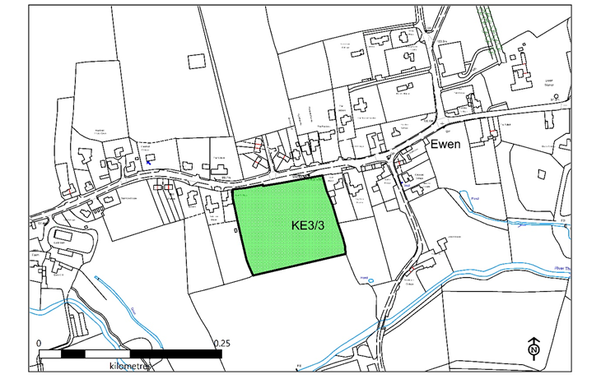

1.3 | Organisation or individual proposing site for designation  Kemble and Ewen Parish Council
1.4 | Ownership of site if known  Information on land ownership can be obtained from the Land Registry. Some land parcels are not registered however local people may know the owner.
1.5 | Is the owner of the site aware of the potential designation? Do they support the designation? (Sites may be designated as Local Green  Spaces, even if there are objections from the site owners)
 | Not known. The site was added to the LGS policy following the NDP consultation in response to representations.
1.6 | Photographs of site
Insert here or attach separately
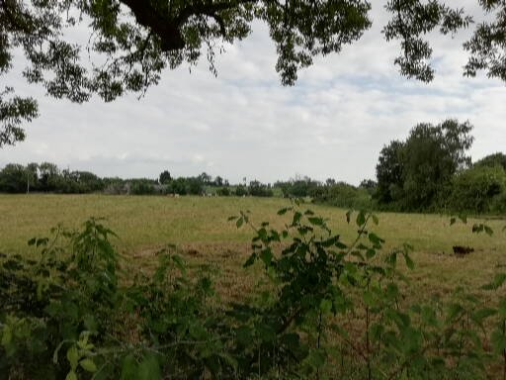

1.7 | Community served by the potential Local Green Space  i.e. does the site serve the whole village/town or a particular geographic area or group of people?
 | Yes, it is an important open area in the centre of the village of significance for the landscape and the character of the village.
2 | Planning History
2.1 | Is there currently a planning application for this site? If permitted/allocated, could part of the overall site still be used as a Green Open Space?
 | Further Information – Cotswold District Council – planning applications
 | No.
2.2 | Is the site allocated for development in the Local or Neighbourhood Plan? If allocated, could part of the overall site still be used as a Green Open Space?  Further Information – Cotswold District Council – planning policy.
 | To be designated local green space in the neighbourhood plan.
3 | Size, scale and “local nature” of proposed Local Green Space
3.1 | Area of proposed site  1.52 hectares
3.2 | Is the site an “extensive tract of land”?  (Extensive tracts of land cannot be designated as Local Green Space)  e.g. how large is it in comparison to other fields; groups of fields; areas of land in the vicinity etc.? Does the site “feel” extensive or more local in scale?
 | No. The site is the front portion of a larger area of land. The designated area has been selected as the part which is of most importance for the reasons set out above.
3.3 | Is the proposed site “local in character”?  e.g. does the site feel as though it is part of the local area? And why?  How does it connect physically, visually and socially to the local area? What is your evidence?
 | Yes. The site is in the centre of the village, widely visible as it is passed on foot, cycle and car.
4 | Need for Local Green Space
4.1 | Is there a need for a local green space in this location?  e.g. is there a shortage of accessible greenspace in the area? Is there a village needs survey or parish plan that provides evidence of that need. Further information – Natural England (Accessible Natural Greenspace Standard)  Cotswold District Council - Open Spaces, Sport and Recreation Study
 | There is no need for formal accessible space. The designation is needed to preserve the landscape character of the area and the village.
5 | Evidence to show that “the green space is in reasonably close proximity to the community it serves”  Please indicate what evidence you have provided against each point.
5.1 | How far is the site from the community it serves?  Is the site within 2km of the local community?  Possible evidence – a map to show that distance
 | The site is within the village.
5.2 | Are there any barriers to the local community accessing the site from their homes?  e.g. railway line; main road  Possible evidence – a map to show any potential barriers and how those can be overcome.
 | There is no public access to the site, but it is widely visible: see above.
6 | Evidence to show that the green area is “demonstrably special to a local community”  Please indicate what evidence you have provided against each point.
6.1 | Evidence of support from Parish or Town Council e.g. letter of support; Council minutes
 | The Parish Council is promoting the NDP and supports the designation.
6.2 | Evidence of support from other local community groups or individuals. e.g. letters of support; petitions; surveys etc.
 | None.
6.3 | Evidence of support from community leaders  e.g. letters of support from Ward Members; County Councillors; MP etc.  Further information on contact details - Cotswold District Council,  Gloucestershire County Council, House of Commons
 | None.
6.4 | Evidence of support from other groups  e.g. letters of support from organisations such as Campaign to Protect Rural England; Cotswolds Conservation Board; Gloucestershire Wildlife Trust; Gloucestershire Rural Community Council; Cotswold Water Park Trust; local amenity societies; local schools etc.
 | None.
7 | Evidence to show that the green area “holds a particular local significance, for example because of its beauty,” (if applicable) Please indicate what evidence you have provided against each point.
7.1 | Is this criteria relevant to this site?
 | YES.
7.2 | Describe why the community feels that the site has a particular local significance for its beauty.
 | It is an important open area in the centre of the village. The Thames National Footpath crosses the front of the site on its route through Ewen. The break in the frontage adds materially to the quality and character of the village.
7.3 | Site visibility  e.g. is it easy to see the site from a public place? Are there long-distance views of the site? Are there views of the site from any key locations?
 | The site is highly visible from the road/footpath frontage
7.4 | Is the site covered by any landscape or similar designations?  e.g. Area of Outstanding Natural Beauty; Conservation Area; Special  Landscape Area  Further information – Cotswold District Council; Natural England; Cotswolds Conservation Board
 | The site is within the Kemble and Ewen Special Landscape Area designated in the CDC LP policy EN6.
7.5 | Is the site (or the type of site) specifically mentioned in any relevant landscape character assessments or similar documents?  e.g. Cotswolds AONB landscape character assessment. Further information – Cotswold District Council; Natural England; Cotswolds Conservation Board
 | See above.
7.6 | Does the site contribute to the setting of a historic building or other special feature?
 | No.
7.7 | Is the site highlighted in literature or art?  e.g. is the site mentioned in a well-known poem or shown in a famous painting?
 | No.
8 | Evidence to show that the green area “holds a particular local significance for example because of its historic significance” (if applicable)  Please indicate what evidence you have provided against each point.
8.1 | Is this criteria relevant to this site?
 | NO
8.2 | Are there any historic buildings or remains on the site?  e.g. listed buildings; scheduled ancient monuments; registered parks and gardens; war memorials; other historic remains or structures. Further information – Cotswold District Council; English Heritage;  Gloucestershire Historic Environment Record; Gloucestershire Archives; local history society;
 | No.
8.3 | Are there any important historic landscape features on the site?  e.g. old hedgerows; ancient trees; historic ponds or historic garden features  Further information – Cotswold District Council; English Heritage;  Gloucestershire Historic Environment Record; local history society
 | Trees.
8.4 | Did the site play an important role in the historic development of the village or town?  e.g. the old site of the town railway station; the old garden for the manor house etc.
 | No.
8.5 | Did any important historic events take place on the site?
 | No.
8.6 | Do any historic rituals take place on the site? e.g. well-dressing; maypole dancing etc.
9 | Evidence to show that the green area “holds a particular local significance, for example because of its recreational value  (including as a playing field)”, (if applicable)  Please indicate what evidence you have provided against each point.
9.1 | Is this criteria relevant to this site?
 | NO
9.2 | Is the site used for playing sport?  If so what sport? How long has it been used for sports provision? Is this sports provision free or is a club membership required? Further information – Sport England
9.3 | Are the public able to physically access the site?  e.g. are there any public rights of way across the site? Or adjacent to the site? Has access been allowed on a discretionary basis? Is there public access to the whole site or only part? Is there good disabled access to the site? (A site can still be designated even if there is no public access.)  Further information – Gloucestershire County Council
9.4 | Is the site used by the local community for informal recreation? And since when?  e.g. dog walking; sledging; ball games etc
10 | Evidence to show that the green area “holds a particular local significance, for example because of its tranquillity” (if applicable) Please indicate what evidence you have provided against each point.
10.1 | Is this criteria relevant to this site?
 | YES.
10.2 | Do you consider the site to be tranquil?  e.g. are there are any roads or busy areas close by?
 | Yes, it provides an important break in the built frontage in the village which contributes to the quality of the footpath route through the village and provides some relief against the traffic on the road.
10.3 | Is the site within a recognised tranquil area?  e.g. within the Campaign to Protect Rural England’s tranquillity maps
 | No.
11 | Evidence to show that the green area “holds a particular local significance, for example because of the richness of its wildlife”; (if applicable)  Please indicate what evidence you have provided against each point.
11.1 | Is this criteria relevant to this site?
 | NO
11.2 | Is the site formally designated for its wildlife value?  e.g. as a site of special scientific interest; a key wildlife site etc  Further information - Natural England; Gloucestershire Centre for Environmental Records
11.3 | Are any important habitats or species found on the site?  e.g. habitats and species listed in the UK priority habitats and species lists or in the Cotswold Water Park or Gloucestershire Biodiversity Action Plans or protected species or on the red/amber lists of birds of conservation concern.  Further information - Natural England; Gloucestershire Centre for  Environmental Records; National Biodiversity Network; Cotswold Water Park Trust; RSPB
11.4 | What other wildlife of interest has been found on the site?  Further information - Natural England; Gloucestershire Centre for  Environmental Records; National Biodiversity Network; Cotswold Water Park Trust
11.5 | Is the site part of a long-term study of wildlife by members of the local community?  e.g. long-term monitoring of breeding birds.
12 | Evidence to show that the green area “holds a particular local significance, for any other reason”; (if applicable)  Please indicate what evidence you have provided against each point.
12.1 | Is this criteria relevant to this site?
 | NO
12.2 | Are there any other reasons why the site has a particular local significance for the local community?
1 | General Information | Tick if relevant evidence provided
1.1 | Name and address of site  KE3/4, Land off School Road, Kemble
1.2 | Site location plan
Insert here or attach separately
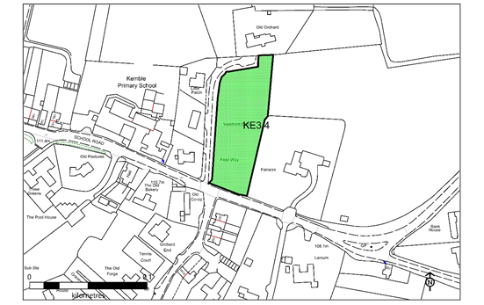

1.3 | Organisation or individual proposing site for designation  Kemble and Ewen Parish Council
1.4 | Ownership of site if known  Information on land ownership can be obtained from the Land Registry. Some land parcels are not registered however local people may know the owner.
1.5 | Is the owner of the site aware of the potential designation? Do they support the designation? (Sites may be designated as Local Green  Spaces, even if there are objections from the site owners)
 | The site’s designation arises as a consequence of the consultation on the draft NDP.
1.6 | Photographs of site
Insert here or attach separately
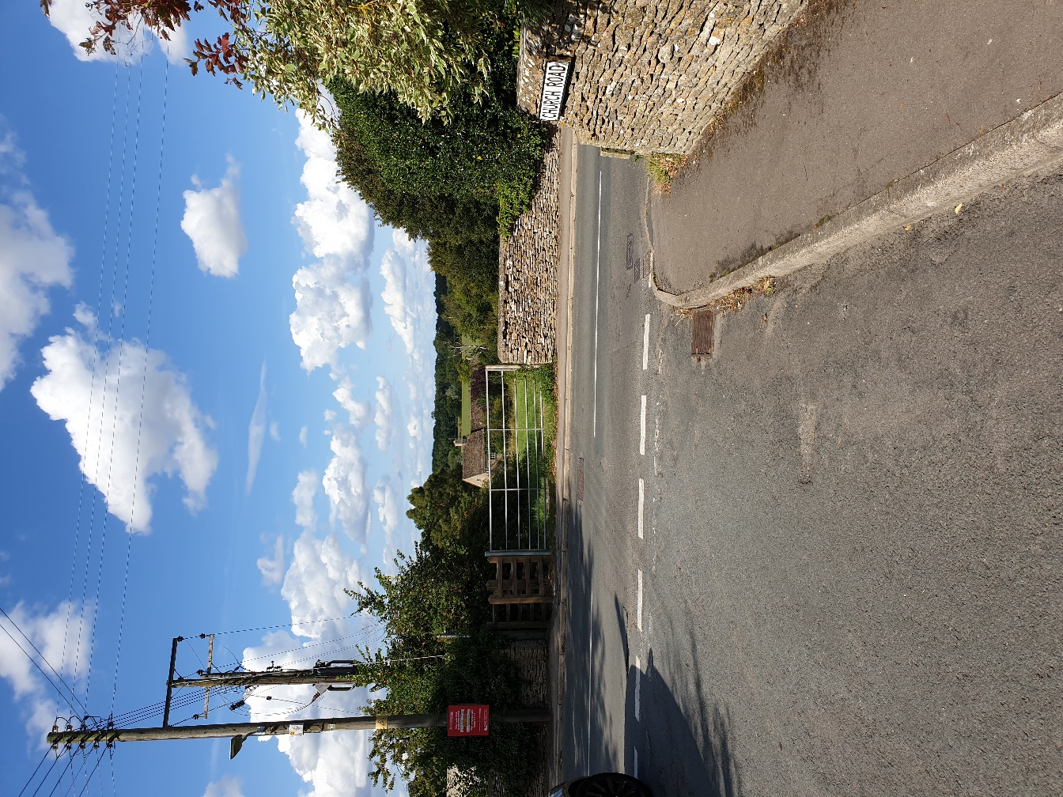

1.7 | Community served by the potential Local Green Space  i.e. does the site serve the whole village/town or a particular geographic area or group of people?
 | The site serves the whole community and is well used by it.
2 | Planning History
2.1 | Is there currently a planning application for this site? If permitted/allocated, could part of the overall site still be used as a Green Open Space?
 | Further Information – Cotswold District Council – planning applications
 | No
2.2 | Is the site allocated for development in the Local or Neighbourhood Plan? If allocated, could part of the overall site still be used as a Green Open Space?  Further Information – Cotswold District Council – planning policy.
 | To be designated local green space in the neighbourhood plan.
3 | Size, scale and “local nature” of proposed Local Green Space
3.1 | Area of proposed site  0.42 hectares
3.2 | Is the site an “extensive tract of land”?  (Extensive tracts of land cannot be designated as Local Green Space)  e.g. how large is it in comparison to other fields; groups of fields; areas of land in the vicinity etc.? Does the site “feel” extensive or more local in scale?
 | No, the site is the exposed and open portion of a larger area. It is well contained within the village and by houses which overlook it.
3.3 | Is the proposed site “local in character”?  e.g. does the site feel as though it is part of the local area? And why?  How does it connect physically, visually and socially to the local area? What is your evidence?
 | Yes, for the reason set out above.
4 | Need for Local Green Space
4.1 | Is there a need for a local green space in this location?  e.g. is there a shortage of accessible greenspace in the area? Is there a village needs survey or parish plan that provides evidence of that need. Further information – Natural England (Accessible Natural Greenspace Standard)  Cotswold District Council - Open Spaces, Sport and Recreation Study
 | There is a need for routes to access the countryside. The site is crossed by Kemble Footpath Number 12 which is an important and well used amenity.
5 | Evidence to show that “the green space is in reasonably close proximity to the community it serves”  Please indicate what evidence you have provided against each point.
5.1 | How far is the site from the community it serves?  Is the site within 2km of the local community?  Possible evidence – a map to show that distance
 | The site is within the village and within the Kemble Conservation Area.
5.2 | Are there any barriers to the local community accessing the site from their homes?  e.g. railway line; main road  Possible evidence – a map to show any potential barriers and how those can be overcome.
 | No.
6 | Evidence to show that the green area is “demonstrably special to a local community”  Please indicate what evidence you have provided against each point.
6.1 | Evidence of support from Parish or Town Council e.g. letter of support; Council minutes
 | The designation of the site is supported by the Parish Council.
6.2 | Evidence of support from other local community groups or individuals. e.g. letters of support; petitions; surveys etc.
6.3 | Evidence of support from community leaders  e.g. letters of support from Ward Members; County Councillors; MP etc.  Further information on contact details - Cotswold District Council,  Gloucestershire County Council, House of Commons
6.4 | Evidence of support from other groups  e.g. letters of support from organisations such as Campaign to Protect Rural England; Cotswolds Conservation Board; Gloucestershire Wildlife Trust; Gloucestershire Rural Community Council; Cotswold Water Park Trust; local amenity societies; local schools etc.
7 | Evidence to show that the green area “holds a particular local significance, for example because of its beauty,” (if applicable) Please indicate what evidence you have provided against each point.
7.1 | Is this criteria relevant to this site?
 | YES
7.2 | Describe why the community feels that the site has a particular local significance for its beauty.
 | The site is an important undeveloped area within the village and the Conservation Area. The village has had a good deal of infill development which has tightened up the pattern of development. This open break provides a very attractive view from the road adjacent to it and from Church Road which slopes down towards it. With its footpath access it gives an immediate opportunity to access what feels like countryside from within the village.
7.3 | Site visibility  e.g. is it easy to see the site from a public place? Are there long-distance views of the site? Are there views of the site from any key locations?
 | Yes. Good views especially from Church Road and School Road.
7.4 | Is the site covered by any landscape or similar designations?  e.g. Area of Outstanding Natural Beauty; Conservation Area; Special  Landscape Area  Further information – Cotswold District Council; Natural England; Cotswolds Conservation Board
 | The site is within the Kemble and Ewen Special Landscape Area designated in the CDC LP Policy EN6. It is within the Kemble Conservation Area.
7.5 | Is the site (or the type of site) specifically mentioned in any relevant landscape character assessments or similar documents?  e.g. Cotswolds AONB landscape character assessment. Further information – Cotswold District Council; Natural England; Cotswolds Conservation Board
 | See above.
7.6 | Does the site contribute to the setting of a historic building or other special feature?
 | No
7.7 | Is the site highlighted in literature or art?  e.g. is the site mentioned in a well-known poem or shown in a famous painting?
 | No
8 | Evidence to show that the green area “holds a particular local significance for example because of its historic significance” (if applicable)  Please indicate what evidence you have provided against each point.
8.1 | Is this criteria relevant to this site?
 | YES
8.2 | Are there any historic buildings or remains on the site?  e.g. listed buildings; scheduled ancient monuments; registered parks and gardens; war memorials; other historic remains or structures. Further information – Cotswold District Council; English Heritage;  Gloucestershire Historic Environment Record; Gloucestershire Archives; local history society;
 | None known but the Archaeology and Planning Solutions Report of December 2017 identifies that the whole area around Kemble has high potential to contain remains as a consequence of the level of activity in the area over millennia.
8.3 | Are there any important historic landscape features on the site?  e.g. old hedgerows; ancient trees; historic ponds or historic garden features  Further information – Cotswold District Council; English Heritage;  Gloucestershire Historic Environment Record; local history society
 | The site is bounded in part by a Cotswold stone wall and surrounded by a rich mixture of trees and hedgerows.
8.4 | Did the site play an important role in the historic development of the village or town?  e.g. the old site of the town railway station; the old garden for the manor house etc.
 | No
8.5 | Did any important historic events take place on the site?
 | No
8.6 | Do any historic rituals take place on the site? e.g. well-dressing; maypole dancing etc.
 | No
9 | Evidence to show that the green area “holds a particular local significance, for example because of its recreational value  (including as a playing field)”, (if applicable)  Please indicate what evidence you have provided against each point.
9.1 | Is this criteria relevant to this site?
 | YES
9.2 | Is the site used for playing sport?  If so what sport? How long has it been used for sports provision? Is this sports provision free or is a club membership required? Further information – Sport England
 | No
9.3 | Are the public able to physically access the site?  e.g. are there any public rights of way across the site? Or adjacent to the site? Has access been allowed on a discretionary basis? Is there public access to the whole site or only part? Is there good disabled access to the site? (A site can still be designated even if there is no public access.)  Further information – Gloucestershire County Council
 | Kemble Footpath Number 12 crosses the site. This is well used and connects to the Thames National trail at Parkers Bridge
9.4 | Is the site used by the local community for informal recreation? And since when?  e.g. dog walking; sledging; ball games etc
 | Yes, walking.
10 | Evidence to show that the green area “holds a particular local significance, for example because of its tranquillity” (if applicable) Please indicate what evidence you have provided against each point.
10.1 | Is this criteria relevant to this site?
 | YES
10.2 | Do you consider the site to be tranquil?  e.g. are there are any roads or busy areas close by?
 | Yes, because it provides an important break in the developed area of the village and the opportunity to immediately access countryside and get away from the road.
10.3 | Is the site within a recognised tranquil area?  e.g. within the Campaign to Protect England’s tranquillity maps
 | No
11 | Evidence to show that the green area “holds a particular local significance, for example because of the richness of its wildlife”; (if applicable)  Please indicate what evidence you have provided against each point.
11.1 | Is this criteria relevant to this site?
 | NO
11.2 | Is the site formally designated for its wildlife value?  e.g. as a site of special scientific interest; a key wildlife site etc  Further information - Natural England; Gloucestershire Centre for Environmental Records
11.3 | Are any important habitats or species found on the site?  e.g. habitats and species listed in the UK priority habitats and species lists or in the Cotswold Water Park or Gloucestershire Biodiversity Action Plans or protected species or on the red/amber lists of birds of conservation concern.  Further information - Natural England; Gloucestershire Centre for  Environmental Records; National Biodiversity Network; Cotswold Water Park Trust; RSPB
11.4 | What other wildlife of interest has been found on the site?  Further information - Natural England; Gloucestershire Centre for  Environmental Records; National Biodiversity Network; Cotswold Water Park Trust
11.5 | Is the site part of a long-term study of wildlife by members of the local community?  e.g. long-term monitoring of breeding birds.
12 | Evidence to show that the green area “holds a particular local significance, for any other reason”; (if applicable)  Please indicate what evidence you have provided against each point.
12.1 | Is this criteria relevant to this site?
 | YES
12.2 | Are there any other reasons why the site has a particular local significance for the local community?
 | The site is of significance because of the combination of factors identified above. An important landscape area, important for informal recreation and important for the preservation of the character and appearance of the Conservation Area.

Appendix 2. Natural Environment Designated Sites
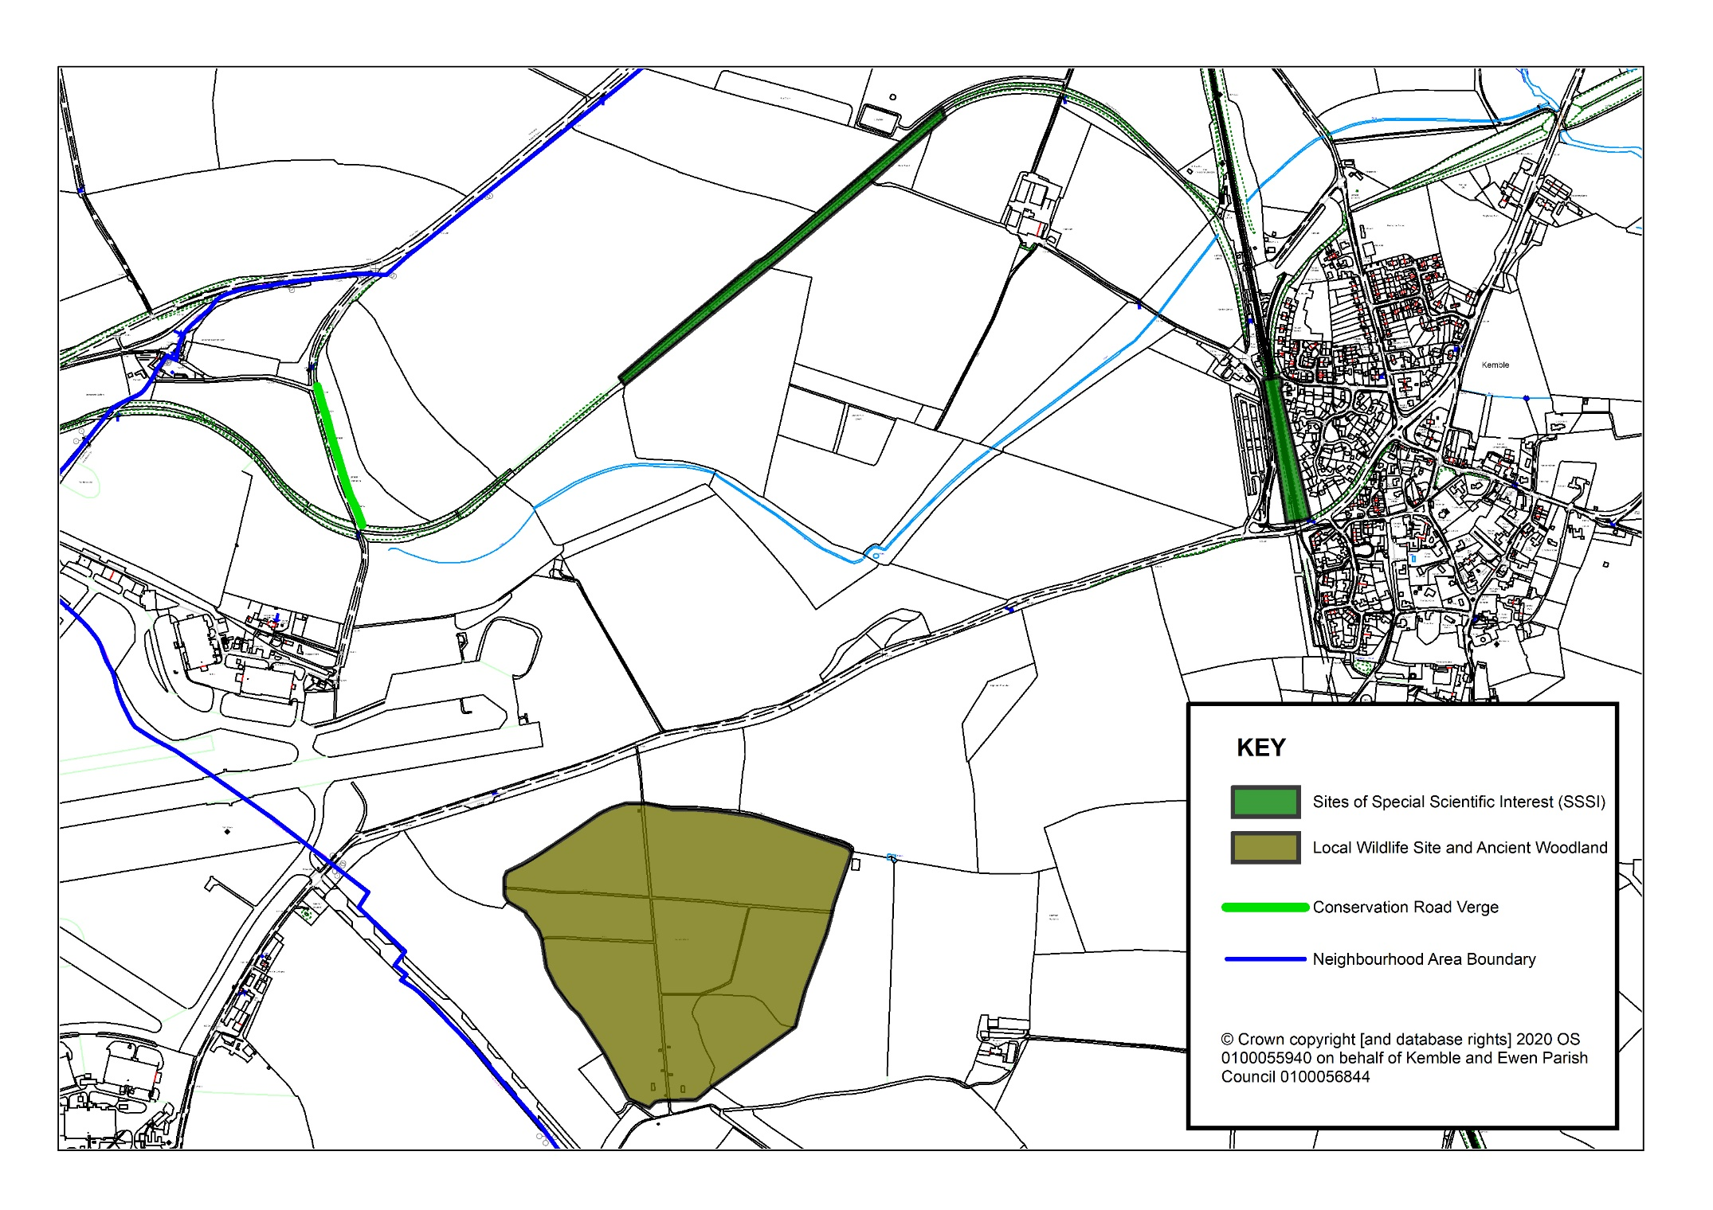
Glossary

The Glossary is neither a statement of law nor an interpretation of the law, and its status is only an introductory guide to planning terminology and should not be used as a source for statutory definitions.
Accessibility: The extent to which employment, goods and services are made easily available to people, either through close proximity, or through providing the required physical links to enable people to go to locations where they are available.
Affordable Housing: Housing that is provided to eligible households at a price/ rent below the market rate, whose housing needs are not met by the market. It includes socially rented, affordable rented and intermediate housing.
Ancient Woodlands: These are defined as areas where there is believed to have been continuous woodland cover since at least 1600 AD. It can include both ancient semi natural and ancient replanted woodlands. They are irreplaceable habitats.
Appropriate Assessment (AA): Under the Habitat Regulations Assessment, stakeholders such as developers/ Local Authorities are required to undertake this assessment when a plan or project is likely to have an impact on any European Environmental conservation designations (i.e. Natura 2000 sites consisting of Special Protected Areas of Conservation, Special Protected Areas, etc.). The overall aim of this assessment is to demonstrate that the plan/ project will not have an adverse impact on the integrity of the environmental designation. Alternatively, the AA will need to demonstrate why the proposed project/ plan is in the overriding public interest and the compensatory measures that will be taken to ensure the overall coherence of the Natura 2000 sites is protected.
Biodiversity: The variety of plants, animals and other living things in a particular area or region. It encompasses habitat diversity, species diversity and genetic diversity.
Brownfield Land: See definition for Previously Developed Land.
Carbon Footprint: The amount of greenhouse gas produced in daily life through the burning of fossil fuels.
Community Infrastructure Levy (C.I.L): This allows Local Authorities to raise funds from developers undertaking new building projects in their area. This is used to fund a wide range of infrastructure (i.e. transport schemes, schools, etc.) that are needed to support the development of their area.
Connectivity: The linkages that exist between key locations.
Developer Contributions: Contributions made by a developer to remedy the impact of development, either by paying money for work to be carried out or by directly providing facilities or works either on or off-site.
Development Plan Document (DPD): These are planning documents forming part of the Local Development Framework (LDF) and which have a status of being part of the development plan. In order to acquire this status, they will be subject to independent scrutiny through a public examination. Certain documents within the LDF must be DPDs, for example a Core Strategy, Site Specific Allocations of land and Area Action Plan where produced. There must also be an adopted Policies Map which may be varied as successive DPDs are adopted. Current Local Planning Regulations no longer use the term DPD and refer to Local Plans instead.
Dwelling: A self-contained building or part of a building used as a residential accommodation, and usually housing a single household. A dwelling may be a house, bungalow, flat, maisonette or residentially converted farm building.
Economic Development: Development, including those within the B Use Classes, public and community uses, and main town centre uses (but excluding housing development).
Environment Agency: This is a Public Body that is responsible for protecting and improving the environment of England and Wales, and for protecting communities from the risk of flooding and managing water resources. They are consulted throughout the plan making and decision-making process in order to promote sustainable development.
Evidence Base: The information and data gathered to justify the policy approach set out in the Neighbourhood Plan including physical, economic, and social characteristics of an area. It consists of consultation responses and the finding of technical studies.
Flood Risk Attenuation: Measures such as tanks and surface ponds that are designed to reduce or prevent water entering an area, sewers and rivers during periods of heavy rainfall with the potential to prevent flooding.
Flood Zone 1: An area with low risk of flooding. This zone comprises land assessed as having a less than 1 in 1000 annual probability of river or sea flooding. Flood Zone 2: An area with a low to medium risk of flooding. This zone comprises land assessed as having between a 1 in 100 and 1 in 1000 annual probability of river flooding or between a 1 in 200 and 1 in 1000 annual probability of sea flooding.
Flood Zone 3a: An area with a high probability of flooding. This zone comprises land assessed as having a 1 in 100 or greater annual probability of river flooding or a 1 in 200 or greater annual probability of flooding from the sea.
Flood Zone 3b: This is an area within a functional floodplain. This zone comprises land where water should flow or be stored in times of flood.
Greenfield Land: Land which has not previously been developed, including land in agriculture or forestry and land in built up areas used for outdoor sport and recreation (including public and private open space and allotments).
Green Infrastructure: A strategically planned and delivered network of high-quality green spaces and other environmental features. It is designed and managed as a multifunctional resource capable of delivering a wide range of environmental and quality of life benefits for local communities. Green Infrastructure includes parks, open spaces, playing fields, woodlands, allotments and private gardens.
Infrastructure Delivery Plan (IDP): The IDP identifies the necessary social, physical and green infrastructure required to support the new development proposed in the Joint Core Strategy for West Northamptonshire up to 2029. The document will be subject to monitoring and regular review.
Lifetime Homes: The Lifetime Homes standard is a set of 16 design criteria that provide a model for building accessible and adaptable homes. This standard is widely used in planning policies and forms part of the Code for Sustainable Homes.
Local Centre: A centre that includes a range of small shops and services of a local convenience nature, serving a small catchment. They might typically include a small supermarket, a newsagent, a sub-post office, a pharmacy and take-away.
Local Development Documents (LDDs): Any document prepared by a local planning authority individually or with other local planning authorities which deals with one or more of the following:
- the development and use of land;
- the allocation of sites for a particular form of development or use;
- environmental, social, design and economic objectives relevant to the development and use of land; and
- development management and site allocations policies which guide the determination of planning applications.
LDDs are referred to in the Regulations as Local Plans and this is the term commonly used in the Joint Core Strategy.
Local Development Framework (LDF): The name for the portfolio of Local Development Documents. It consists of Development Plan Documents, Supplementary Planning Documents, a Statement of Community Involvement, the Local Development Scheme and Annual Monitoring Reports. Together these documents provide the framework for delivering the spatial planning strategy for a local authority area and may also include local development orders and simplified planning zones. The National Planning Policy Framework no longer refers to LDFs and uses the term 'Local Plan' instead.
Local Plan: The plan for the future development of the local area, drawn up by the local planning authority in consultation with the community. In law this is described as the development plan documents adopted under the Planning and Compulsory Purchase Act 2004. Current Core Strategies and other planning policies which under the Regulations would be considered to be development plan documents, form part of the Local Plan. The term includes old policies which have been saved under the 2004 Act.
Local Strategic Partnership: This is a partnership that brings together organisations from public, private, community and voluntary sector in a local authority area, so that different initiatives and services support each other and work together. The partnership is responsible for producing a Sustainable Community Strategy/ Vision, setting out their local priorities and the key actions that may need to be taken to achieve these, in order to enhance the social, economic and environmental well-being of their area.
Localism Act: This is an Act of Parliament that changes the powers of local government in England. The Act includes provisions for local government finance, town and country planning, the Community Infrastructure Levy and the authorisation of nationally significant infrastructure projects.
Mixed Use (or Mixed Use Development): Provision of a mix of complementary uses, such as residential, community and leisure uses, on a site or within a particular area.
Mode: The type of transport being used for a journey.
National Planning Policy Framework (NPPF): This document sets out the Government's planning policies for England and how these are expected to be applied. It provides a framework within which local people and their accountable councils can produce their own distinctive local and neighbourhood plans, which reflect the needs and priorities of their communities.
Parish Plans: Are prepared by Parish Councils and other local community groups and set out a vision for their local area and usually include an action plan of how to achieve the vision. Parish Plans can be used to inform the development of planning policy at the local level.
Physical Infrastructure: Includes existing and future development required to support utilities, transport and waste management.
Previously Developed Land (PDL): Land which is or was occupied by a permanent structure (excluding agricultural and forestry buildings) and associated fixed surface infrastructure, including the curtilage of (land attached to) buildings. It includes defence buildings and land used for mineral or waste extraction when there is no requirement for subsequent restoration. Land in built up areas such as private residential gardens, parks, recreation grounds and allotments are not considered as PDL. PDL is still commonly referred to as brownfield land.
Public Realm: Areas available for everyone to use, including streets, squares and parks.
.
Section 106 Agreement/ Contribution: Refers to Section 106 of the Town and Country Planning Act 1990 and is a legally binding agreement or planning obligation with a landowner in association with the granting of planning permission. These agreements are a way of delivering or addressing matters that are necessary to make a development acceptable in planning terms. They are increasingly used to support the provision of services and infrastructure, such as highways, recreational facilities, education, health and affordable housing.
Site of Specific Scientific Interest (SSSI): A site or area designated as being important due to its wildlife plants or flowers and/ or unusual or typical geological features. SSSIs are identified by Natural England and have protected status under Wildlife and Countryside Act 1981.
Social Infrastructure: Includes education, healthcare, sports facilities, cultural and community facilities.
Special Protection Area (SPA): A SPA is a designation under the European Union Directive on the Conservation of Wild Birds. Under the Directive, Member States of the European Union (EU) have a duty to safeguard the habitats of migratory birds and certain threatened birds.
Strategic Environment Assessment: A generic term used to describe environmental assessment as applied to policies, plans and programmes. The European 'SEA Directive' (2001/42/EC) requires a formal 'environmental assessment of certain plans and programmes, including those in the field of planning and land use.
Strategic Flood Risk Assessment (SFRA): Assessment of all forms of flood risk from groundwater, surface water, impounded water bodies, sewer, river and tidal sources, taking into account future climate change predictions. This allows Councils to use this information to locate future development primarily in low flood risk areas (Level 1 SFRA). For areas that have a higher risk of flooding, the SFRA examines the capacity of the existing flood prevention infrastructure (i.e. drainage) and identifies all the measures that any potential development may need to take to ensure that it will be safe and will not increase flood risk to third parties (Level 2 SFRA).
Strategic Housing Land Availability Assessment (SHLAA): A technical document which assesses the amount and nature of land which could be made available for housing development. It is part of the evidence base that will inform the plan making process.
Strategic Housing Market Assessment (SHMA): A technical study which assesses housing need and demand across a defined market area, and which is used to inform housing and planning policies.
Supplementary Planning Document (SPD): Provides additional guidance on matters covered by a DPD/ Local Plan. They will be an important consideration in determining planning applications.
Sustainable Development: Development which meets the needs of the present, without compromising the ability of future generations to meet their own needs.
Sustainable Urban Extensions: These are defined as a planned expansion of a city or town that can contribute to creating more sustainable patterns of development when located in the right place, with well-planned infrastructure including access to a range of facilities and when developed at appropriate densities.
Topography: The gradient and variations in height within a landscape.
Viability Appraisal: An assessment of a proposed development to ensure all elements for the development, including required infrastructure and any required financial contributions can be successfully delivered in an economic context.

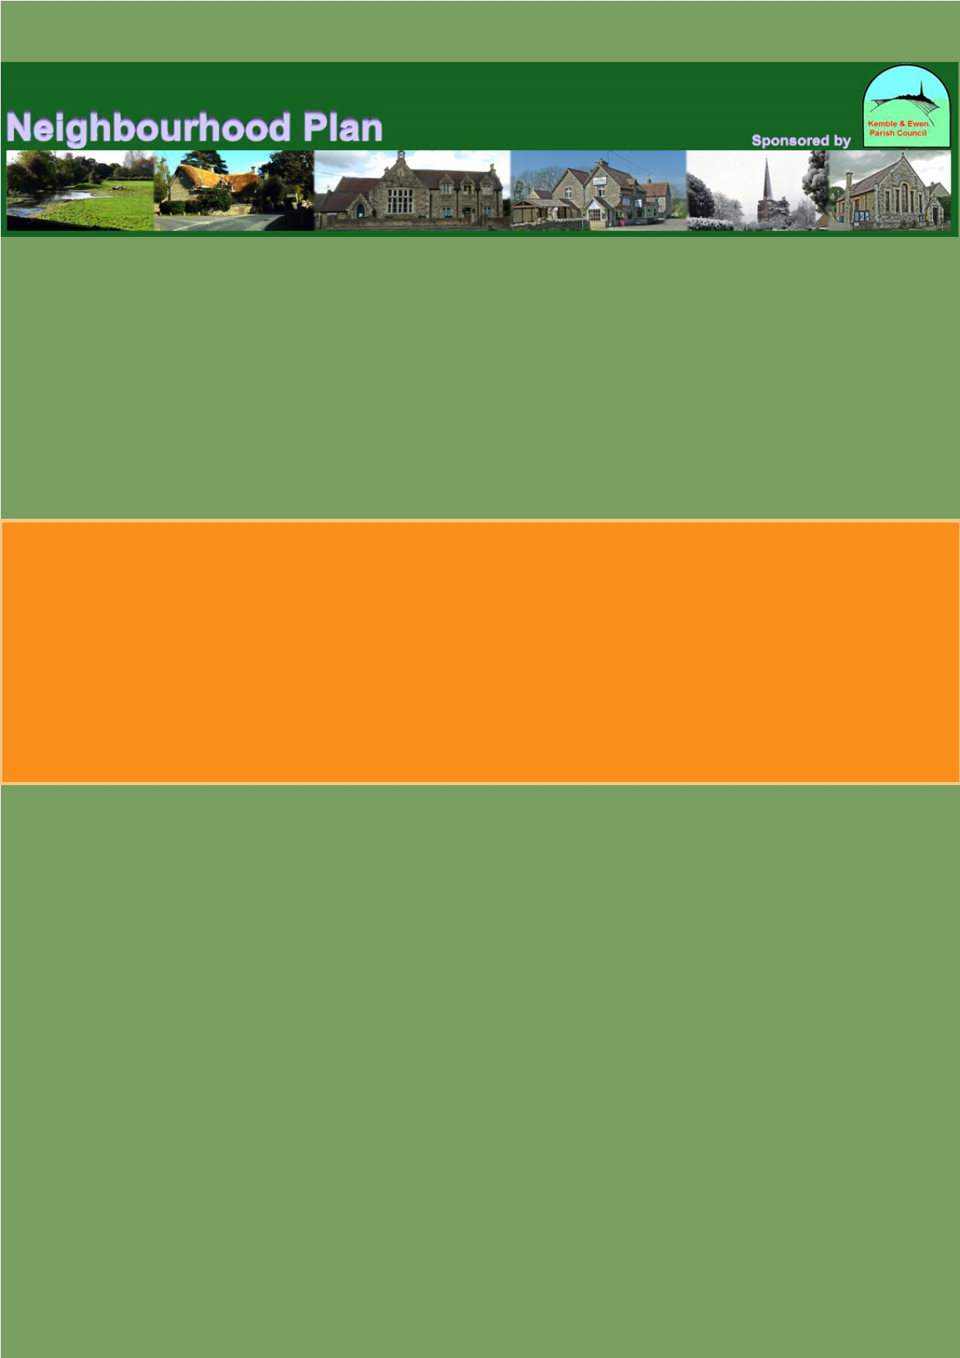

https://www.gov.uk/government/uploads/system/uploads/attachment_data/file/6077/2116950.pdf
https://www.cotswold.gov.uk/media/1739444/1205-Housing-Land-Supply-Report-May-2019-.pdf

